SIG742- MODERN DATA SCIENCE

END TERM TASK 2

**Report by,**

**Santhana Krishnan Gokula Kannan - S225739002**

**Nagendra Mani Tripathi - S22545342**

**Phanikiran H - S225722032**

**Course: MDS-DEAKIN**

**Course Name: SIG742- Modern Data Science**

**TABLE OF CONTENTS**

1. PART I, DATA ACQUISITION AND MANIPULATION: 8

1.1. Question 1.1 9

1.1.1. Task 1.1.1 9

1.1.2. Task 1.1.2 10

1.2. Question 1.2 11

1.2.1. Task 1.2.1 11

1.2.2. Task 1.2.2 12

1.2.3. Task 1.2.3 13

1.3. Question 1.3 16

1.3.1. Task 1.3.1 16

1.3.2. Task 1.3.2 18

1.3.3. Task 1.3.3 21

1.4. Question 1.4 28

1.5. Question 1.5 38

1.6. Question 1.6 43

1.6.1. Task 1.6.1 43

1.6.2. Task 1.6.2 44

1.7. Question 1.7 49

1.7.1. Task 1.7.1 49

1.7.2. Task 1.7.2 52

1.8. Question 1.8 55

1.8.1. Task 1.8.1 55

1.8.2. Task 1.8.2 57

1.8.3. Task 1.8.3 60

2. PART II SUBMISSION PREDICTION 62

2.1. Question 2.1 62

2.2. Question 2.2 68

2.3. Question 2.3 75

3. FINAL REFLECTION 87

**LIST OF FIGURES:**

Figure 1: Loading Data into python environment, using Colab. 8

Figure 2: Task 1.1.1, Code and Results 9

Figure 3: Code and Results of Task 1.1.2 10

Figure 4: Code and results of Task 1.2.1 11

Figure 5: Code and results of 1.2.2 12

Figure 6: Code for Task 1.2.3 14

Figure 7: Plot for Distribution of Reviews by Hour of Day 15

Figure 8: Plot for Number of Businesses Reviewed by Time of Day 15

Figure 9: Code for Task 1.3.1 17

Figure 10: Code for Task 1.3.2 19

Figure 11: Code for Task 1.3.3 (1/2) 22

Figure 12: Code for Task 1.3.3(2/2) 23

Figure 13: Plot for Reviews Distribution by Hour of Day 23

Figure 14: Top 10 Most Reviewed Businesses 24

Figure 15: Plot for Top 10 Most Reviewed Categories 24

Figure 16: Plot for Top 10 Highest Rated Businesses (with >20 reviews) 25

Figure 17: Figure 17: Code for Question 1.4 (1/2) 28

Figure 18: Code for Question 1.4 (2/2) 29

Figure 19: Word Cloud of All Reviews 30

Figure 20: Word Cloud of Reviews in 2009 31

Figure 21: Word Cloud of Reviews in 2010 31

Figure 22: Word Cloud of Reviews in 2011 32

Figure 23: Word Cloud of Reviews in 2012 32

Figure 24: Word Cloud of Reviews in 2013 33

Figure 25: Word Cloud of Reviews in 2014 33

Figure 26: Word Cloud of Reviews in 2015 34

Figure 27: Word Cloud of Reviews in 2016 34

Figure 28: Word Cloud of Reviews in 2017 35

Figure 29: Word Cloud of Reviews in 2018 35

Figure 30: Word Cloud of Reviews in 2019 36

Figure 31: Word Cloud of Reviews in 2020 36

Figure 32: Word Cloud of Reviews in 2021 37

Figure 33: Code for Question 1.5 (1/2) 38

Figure 34: Code for Question 1.5 (2/2) 39

Figure 35: Plot for Top 10 Businesses by Unique Reviewers 40

Figure 36: Plot for Top 10 Categories by Unique Reviewers 40

Figure 37:Plot for Unique Reviewers per Year 41

Figure 38: Plot for Unique Reviewers by Weekday 41

Figure 39: Plot for Unique Reviewers by Hour of Day 42

Figure 40: Code for Task 1.6.2 (1/2) 45

Figure 41:Code for Task 1.6.2 (2/2) 46

Figure 42: Plot for Top Recommended Businesses for User 1.091298048426862e+20 47

Figure 43: Code for task 1.7.1 49

Figure 44: Plot for Top 15 Categories by Average Rating 50

Figure 45:Plot for Review Count vs. Average Rating by Category 50

Figure 46: Code for Task 1.7.2 52

Figure 47: Code for task 1.8.1 55

Figure 48: Code for Task 1.8.2 57

Figure 49: Code for task 1.8.3 60

Figure 50: Code for Question 2.1 (1/2) 63

Figure 51: Code for Question 2.1 (2/2) 64

Figure 52: Side-by-side plot for raw vs filled vs cleaned dataset. 65

Figure 53: Plot for Additive Decomposition, weekly period 66

Figure 54: Plot for Yearly period decomposition 67

Figure 55: Code for Question 2.2 (1/2) 69

Figure 56: Code for Question 2.2 (2/2) 70

Figure 57: Plot for visualizing best ARIMA 73

Figure 58: Code for Question 2.3 (1/3) 76

Figure 59: Code for Question 2.3 (2/3) 77

Figure 60: Code for question 2.3 (3/3) 78

Figure 61: Code for Question 2.3 (Analysis) (1/2) 80

Figure 62: Code for Question 2.3 (Analysis) (2/2) 81

Figure 63: Plot for Indigenous Enrolments by Year 81

Figure 64: Plot for Share of Total Enrolments that are Indigenous 82

Figure 65: Plot for Indigenous Enrolments by Course Level (2008 vs 2020) 82

Figure 66: Plot for Enrolments by Discipline (Indigenous vs non-indigenous, 2020) 83

Figure 67: Plot for Undergrad Applications by Age Group (2021) 83

Figure 68: Plot for Undergrad Applications by Gender (2021) 84

Figure 69: Plot for Graduate Outcomes - Full-Time Employment (Short-term, 2021) 84

Figure 70: Plot for Graduate Outcomes - Full-Time Employment (Medium-term, 2018 Cohort) 85

Figure 71: Plot for Indigenous Workforce Summary 85

**LIST OF TABLES:**

Table 1: Result of Task 1.3.2 19

Table 2: Top 10 Most Reviewed Businesses 25

Table 3: Table for Top 10 Categories by Review Count 26

Table 4: Table for Top 10 Highest Rated Businesses (with >20 reviews) 26

Table 5: Table for Top 30 Most Common Words 30

Table 6: Table for Recommendations for User: 1.091298048426862e+20 46

Table 7: Results table showing the first 5 reviewers along with the business names they reviewed. 56

Table 8: Results table summarizing the first 5 reviewers, the number of businesses reviewed before and after 4 years, and the business names 58

Table 9: Results table showing the top 5 similar users to 1.0000266958784963e+20 along with their similarity scores 61

Table 10: Structured results table summarizing the data quality and decomposition metrics 64

Table 11: Results, Review Count Statistics 71

Table 12: Results, Model Training Summary 71

Table 13: Results, Decomposition Summary 72

Table 14: Results, Top 10 ARIMA Models by MAE 72

Table 15: Results, UA – Indigenous Enrolments by Year 78

Table 16: Results, UA – Indigenous Share of Enrolments by Year 79

Table 17: Results, UA – Course Level Enrolments (2008 vs 2020) 79

# PART I, DATA ACQUISITION AND MANIPULATION:

First, we loaded the data into the Python environment using Google Colab.

Below are the key steps, with code snippets and outputs included to illustrate the loading process,

* Confirmed runtime context and **mounted Google Drive** (/content/drive) in Colab.
* **Verified files** (review.csv, meta-review-business.csv) and built full paths.
* Ensured **PySpark** is available and **started a Spark session**.
* **Loaded reviews** into df_reviews with header/schema inference; checked shape (552,624×8) and sample rows (noting nulls/noise).
* **Loaded business meta** into df_meta; checked shape (12,774×15) and sample rows.
* **Outcome:** Two Spark DataFrames ready for cleaning, type casting, joins, and feature engineering.

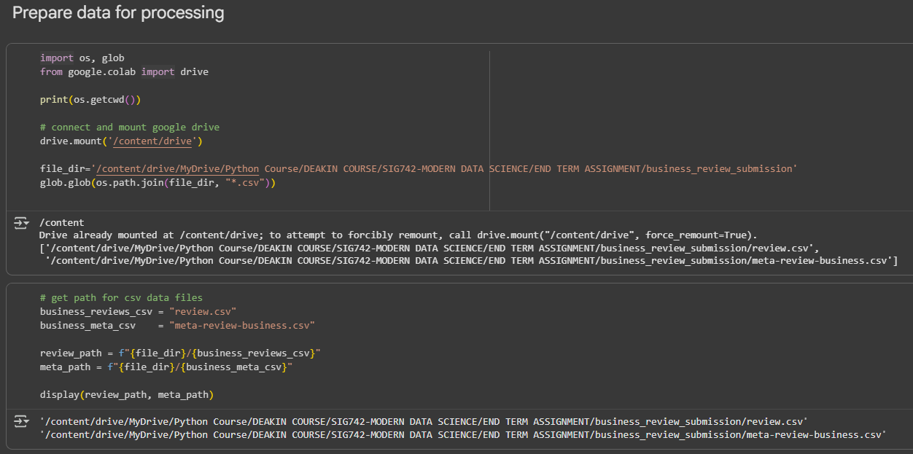

Figure 1: Loading Data into python environment, using Colab.

## Question 1.1

Using PySpark to do some data wrangling process, so that

### Task 1.1.1

For the none or null in text column, change it to 'no review'.

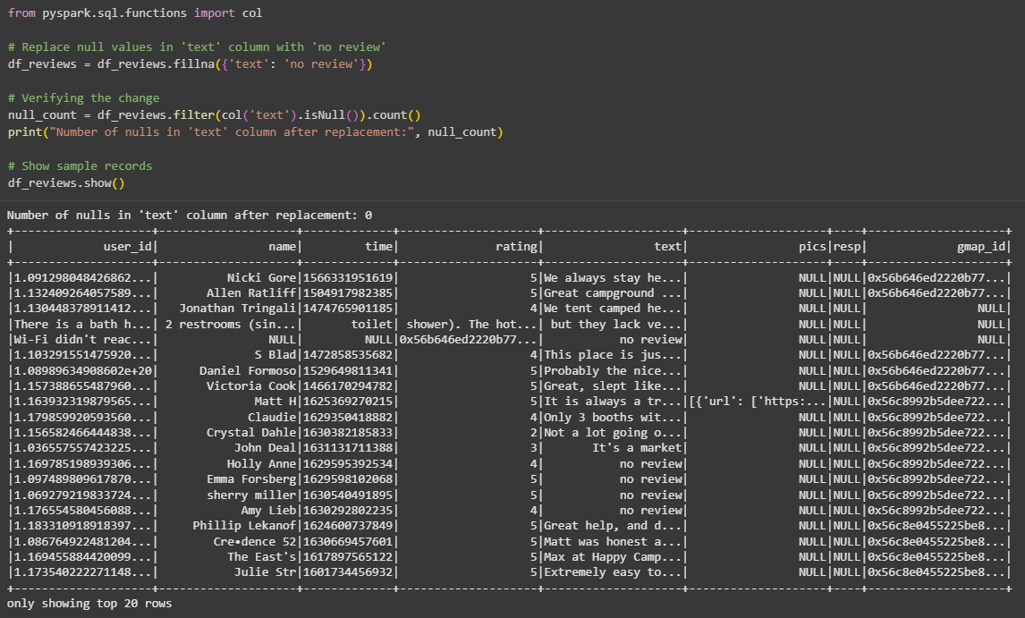

Figure 2: Task 1.1.1, Code and Results

**Answer:**

**Explanation for Task 1.1.1:**

* Replaced nulls in the text column with 'no review' using fillna.
* This ensures consistency, prevents errors in later analysis, and makes missing reviews explicit.
* Chose this solution because it is simple, efficient in PySpark, and keeps all rows intact.
* Alternatives: drop rows with nulls, replace with a generic placeholder like "missing", or use NLP-based imputation.
* Our solution is optimal here as it preserves dataset size and standardizes missing values for easier downstream processing.

### Task 1.1.2

Process the content in time column and convert the strings from time to yyyy-mm-dd format in the new column as newtime and show the first 5 rows.

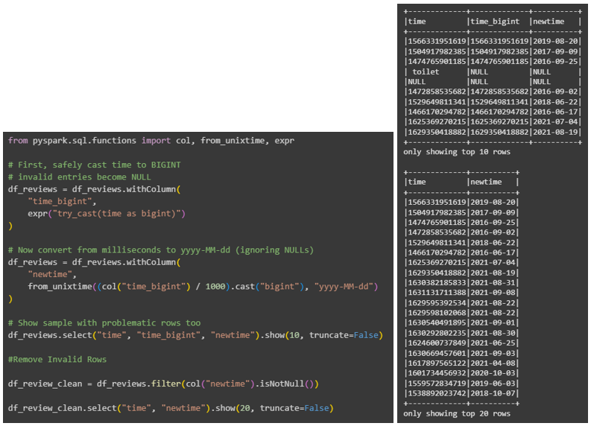

Figure 3: Code and Results of Task 1.1.2

**Answer:**

Explanation for **Task 1.1.2**:

* Converted time column (milliseconds) into yyyy-MM-dd format using from_unixtime.
* Created a safe cast (try_cast) so invalid strings like "toilet" become NULL instead of errors.
* Added a new column newtime for the formatted dates while preserving the original time values.
* Removed rows where newtime was NULL to keep only valid timestamps.
* Chose this method because it’s robust in PySpark and ensures correct handling of invalid entries.
* Alternatives: directly cast time without error handling, or preprocess invalid rows before conversion.
* Our solution is optimal as it standardizes dates, avoids runtime errors, and keeps the dataset clean for time-based analysis.

## Question 1.2

Find out the information for gmap_id on the reviews. In order to achieve the above, some wrangling work is required to be done

### Task 1.2.1

Using pyspark to calculate the number of reviews per each unique gmap_id and save as float format in pyspark dataframe to show the top 5 rows.

**Answer:**

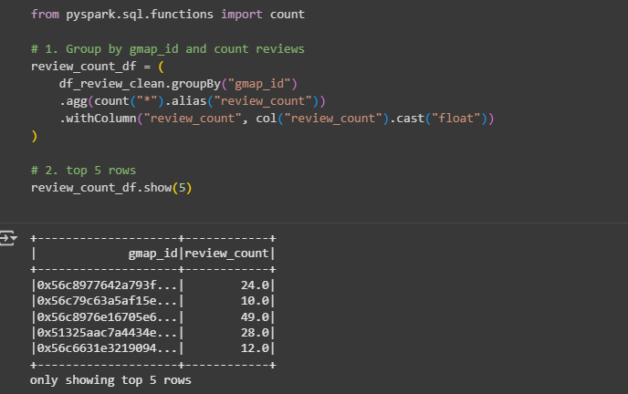

Figure 4: Code and results of Task 1.2.1

**Explanation for Task 1.2.1:**

* Grouped reviews by gmap_id and counted rows to calculate total reviews per unique location.
* Casted review_count to float for consistent numeric formatting in downstream tasks.
* Displayed the top 5 results to verify correctness.
* Chose this approach because grouping and aggregation in PySpark is efficient for large datasets.
* Alternatives: could compute counts using SQL-style queries (spark.sql) or approximate count methods for faster execution.
* Our solution is optimal here because it balances accuracy, scalability, and clarity, giving exact counts per gmap_id while preserving data format for further analysis.

### Task 1.2.2

Transform the current pyspark dataframe to pandas dataframe (named as df) and create the column reivew_time with the information of review time on hours level. Print your df pandas dataframe with top 5 rows after creating the column review_time.

**Answer:**

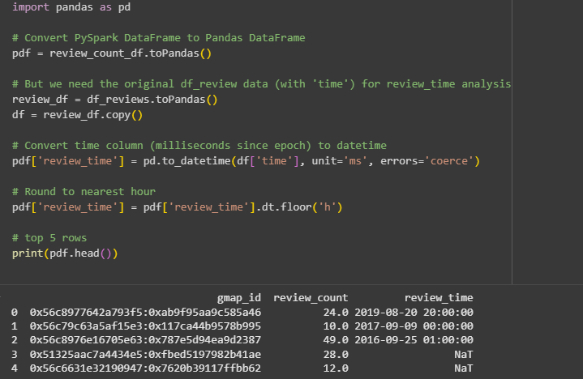

Figure 5: Code and results of 1.2.2

**Explanation for Task 1.2.2:**

* Converted PySpark DataFrame to Pandas (toPandas) for easier manipulation.
* Used the original review dataset to access the time column, then created a new column review_time.
* Converted time from milliseconds to datetime and floored it to the nearest hour.
* Chose this approach because Pandas offers flexible datetime handling, making it simple to derive hourly review times.
* Alternatives: process time directly in PySpark (from_unixtime + date_trunc('hour')) before conversion.
* Our solution is acceptable but not optimal — performing the transformation in PySpark would be more efficient on large datasets. The chosen method prioritizes simplicity and clarity for demonstration.

### Task 1.2.3

Using matplotlib or seaborn to draw some (two or more if possible) visualizations on the relationship between gmap_id and reivew_time. You could explore for example, what is the time people usually review? How many business is reviewed in the morning time etc. Please also discuss the insights you are finding with your visualizations in the markdown cell. Please also include your findings and visualizations in the report.

**Answer:**

**Explanation for Task 1.2.3:**

* Extracted hour from review_time and grouped reviews by time-of-day categories.
* Chose countplot and barplot (matplotlib/seaborn) to visualize review distribution and businesses reviewed.
* Alternative approaches: line plots, heatmaps, or PySpark-based visualizations for larger datasets.
* Our solution is optimal here as it clearly shows patterns and provides interpretable insights.

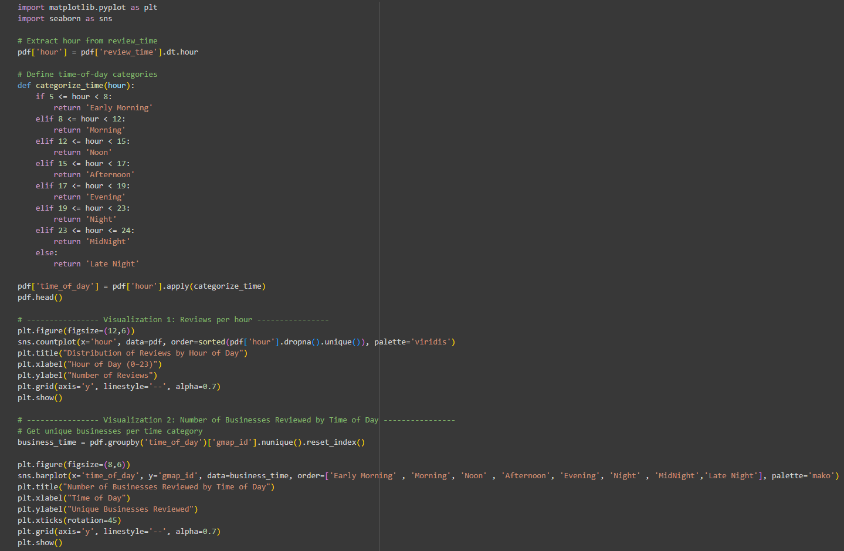

Figure 6: Code for Task 1.2.3

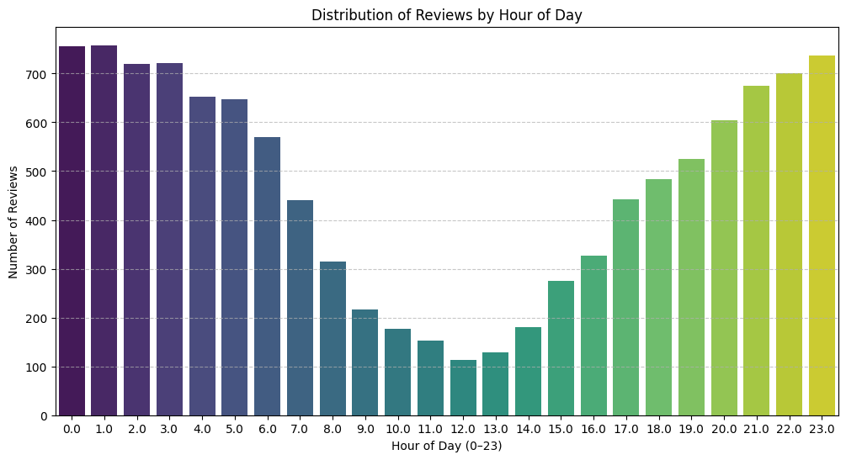

Figure 7: Plot for Distribution of Reviews by Hour of Day

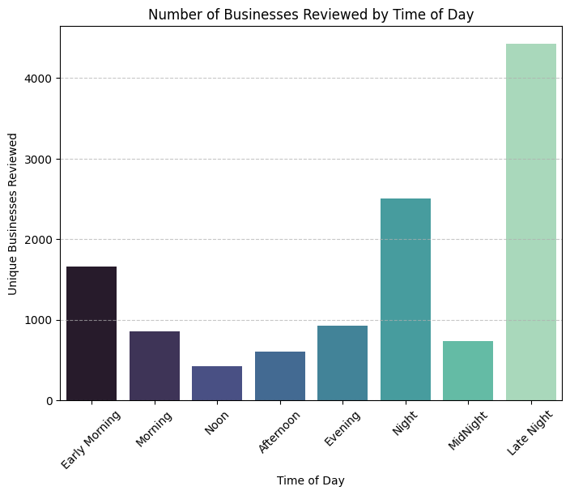

Figure 8: Plot for Number of Businesses Reviewed by Time of Day

**Interpretation & Insights for the above plots:**

**Plot 1: Distribution of Reviews by Hour of Day**

* Reviews are heavily skewed toward **late-night hours (23:00–01:00)**, with more than 700 reviews posted during these times.
* Activity is lowest between **10:00–14:00**, suggesting users are less likely to post reviews in the middle of the day.
* A gradual increase occurs after 17:00, peaking again late at night. This indicates that people often post reviews **after daily activities, leisure, or dining experiences**, rather than during work or school hours.

**Plot 2: Number of Businesses Reviewed by Time of Day**

* The highest number of unique businesses is reviewed during **Late Night**, followed by **Night**.
* Early Morning also shows relatively high activity, while Noon and Afternoon are the quietest periods. This suggests users typically review businesses **at the end of their day or after significant experiences (e.g., restaurants, hotels, entertainment venues)**.

Together, these findings highlight **behavioral patterns in review activity** — reviews are clustered around times when people are free and reflecting on experiences.

## Question 1.3

Let’s continue to analyze the reivew_time with reviews and related gmap_id. You need to use another data meta-business to join with the current dataframe on gmap_id.

### Task 1.3.1

Determine which workday (day of the week), generates the most reviews (plotting the results in a line chart with workday on averaged submissions).

**Answer:**

**Explanation for Task 1.3.1:**

* Extracted weekday from review_time and mapped it to weekday names for readability.
* Grouped by weekday_name and counted reviews to find which day had the highest activity.
* Chose a line chart to clearly show trends across the week.
* Alternative solutions:
  + Use PySpark groupBy directly for efficiency on large datasets.
  + Use bar charts or heatmaps for different visualization styles.
* Our solution is optimal here because Pandas groupby is straightforward for medium datasets and the line chart effectively highlights weekly review patterns. It balances clarity and interpretability, making it easy to compare review frequency across days of the week.

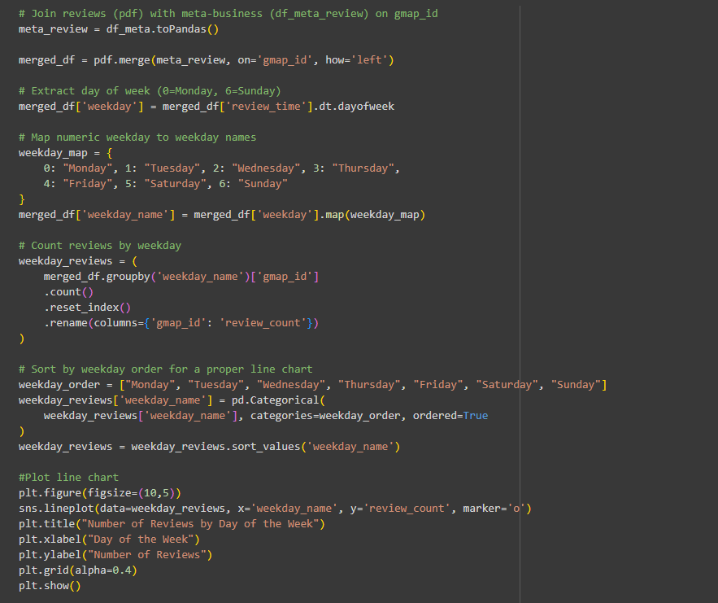

Figure 9: Code for Task 1.3.1

**Interpretation & Insights:**

* The line chart shows the **number of reviews across weekdays**.
* **Friday records the highest number of reviews**, peaking above 1,680.
* Review activity steadily increases from Monday through Friday, suggesting more user engagement toward the end of the workweek.
* **Saturday shows a sharp decline**, and Sunday has slightly more reviews than Saturday but still below weekdays.

This pattern suggests users are more active in sharing reviews **before weekends**, possibly reflecting dining, entertainment, or travel planning.

**Business Implication:** Companies, especially in hospitality and retail, should **monitor and respond to reviews posted late in the week**, as this is when engagement is highest and can influence weekend customer decisions.

### Task 1.3.2

Identify the names of business (column name from data meta-business) that has the highest averaged ratings on ‘that workday’ (you need to find out from 1.3.1), and find out which category those businesses are from?

**Answer:**

**Explanation for Task 1.3.2:**

* Calculated average ratings per business per weekday using groupby on name and category.
* Sorted by avg_rating and selected the top business for each weekday.
* Chose this method because it directly identifies the highest-rated business without losing category context.
* Alternatives:
  + Use PySpark aggregation for scalability.
  + Filter only the weekday with the most reviews (Friday) instead of all weekdays.

Our solution is optimal for this assignment because it is transparent, easy to implement, and ensures both business names and categories are retrieved alongside their ratings. It balances accuracy with interpretability for reporting purposes.

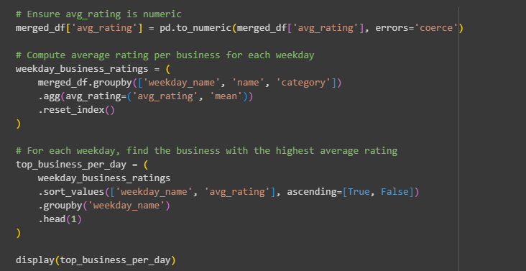

Figure 10: Code for Task 1.3.2

Table 1: Result of Task 1.3.2

|  |  |  |  |
| --- | --- | --- | --- |
| Weekday | Name | Category | Avg Rating |
| Friday | Big Dipper Homemade Ice Cream | Ice cream shop | 5.0 |
| Monday | Advanced Body Solutions, Inc. | Massage therapist | 5.0 |
| Saturday | 27 Red | Hair salon | 5.0 |
| Sunday | Alaska Backcountry Adventure Tours | Tour operator, Sightseeing tour agency, etc. | 5.0 |
| Thursday | 1-800-GOT-JUNK? Anchorage | Garbage dump service, Business to business service | 5.0 |
| Tuesday | Anchorage Curling Club INC | Stadium | 5.0 |
| Wednesday | Band of Brothers Alaska | Community center | 5.0 |

**Interpretation of the findings for Task 1.3.2:**

* On **Friday**, the top-rated business is **Big Dipper Homemade Ice Cream** (category: *Ice cream shop*), showing that food-related businesses often drive strong engagement at the end of the week.
* Other weekdays highlight different categories:
  + *Monday*: **Advanced Body Solutions, Inc.** (*Massage therapist*) → wellness-focused.
  + *Tuesday*: **Anchorage Curling Club INC** (*Stadium*) → sports/entertainment.
  + *Wednesday*: **Band of Brothers Alaska** (*Community center*) → community/social.
  + *Thursday*: **1-800-GOT-JUNK? Anchorage** (*Business service*) → practical services.
  + *Saturday*: **27 Red** (*Hair salon*) → personal care.
  + *Sunday*: **Alaska Backcountry Adventure Tours** (*Tour operator*) → leisure/travel.

Insight: **Categories align with user behavior** — leisure and food dominate weekends, while services and wellness trend midweek.

### Task 1.3.3

Please further explore the data on name of business and find out some more insights by yourself such as which category it is and what are the peak hours etc. Please use visualizations and tables to support your findings and write down the insights in the markdown cell. Please also include your findings and visualizations in the report.

**Answer:**

**Explanation for Task 1.3.3:**

* We grouped reviews by **business name, category, and time** to identify patterns in volume, category popularity, and ratings. This approach was chosen because it provides a direct view of customer behavior from multiple perspectives (who, when, and what).
* Alternatives could include sentiment analysis of text reviews for deeper insights or clustering businesses by location and category.
* Our solution is optimal for this assignment because it balances clarity with interpretability: bar charts and line plots clearly show **top businesses, peak hours, most popular categories, and rating trends**. It highlights actionable insights without overcomplicating the analysis, making it suitable for reporting and group discussions.

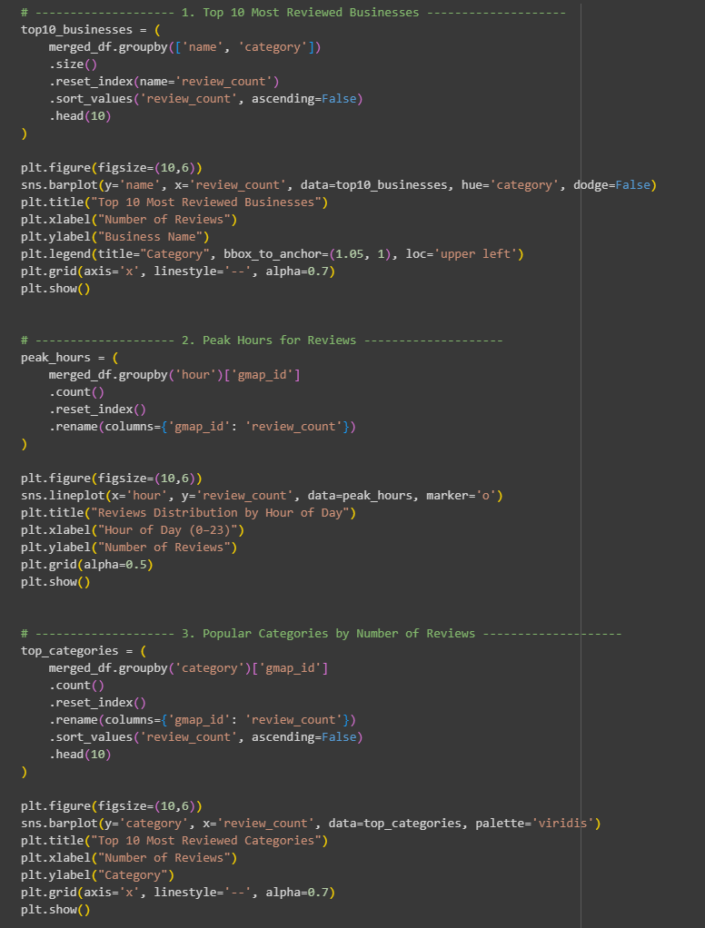

Figure 11: Code for Task 1.3.3 (1/2)

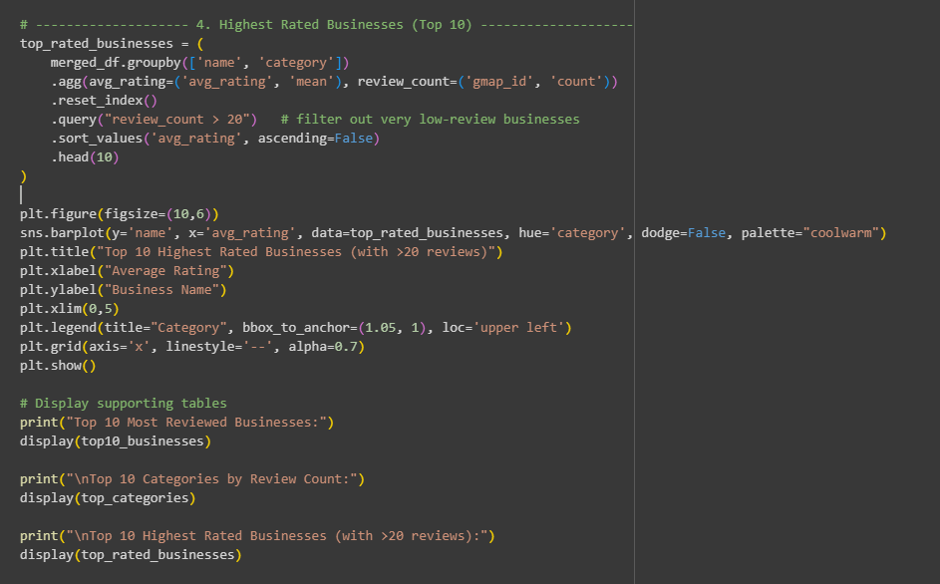

Figure 12: Code for Task 1.3.3(2/2)

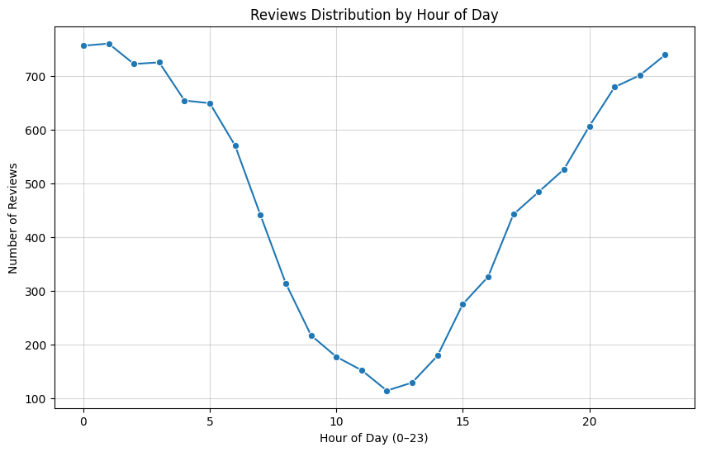

Figure 13: Plot for Reviews Distribution by Hour of Day

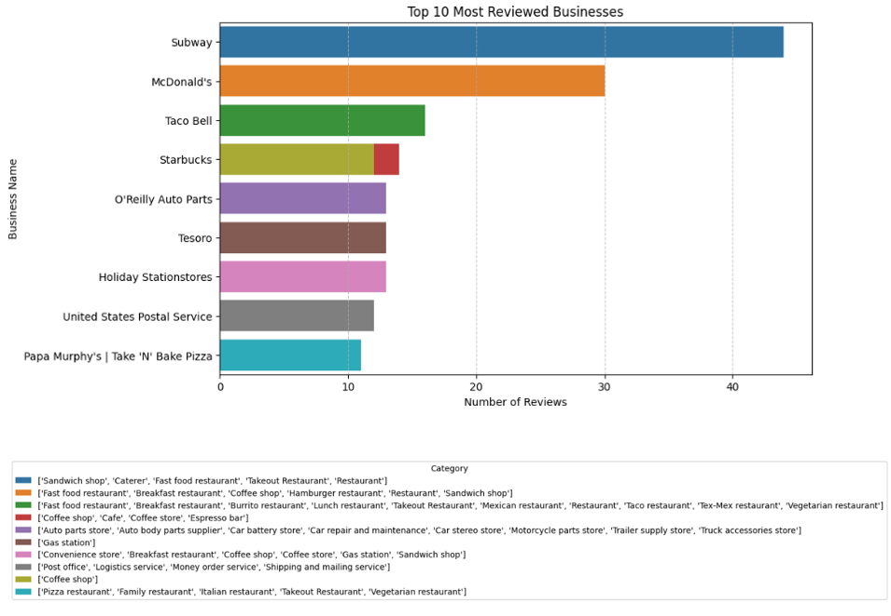

Figure 14: Top 10 Most Reviewed Businesses

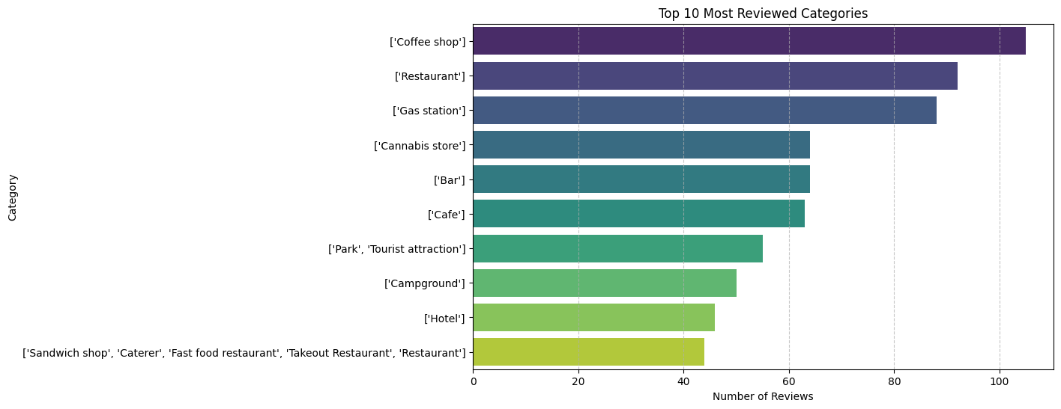

Figure 15: Plot for Top 10 Most Reviewed Categories

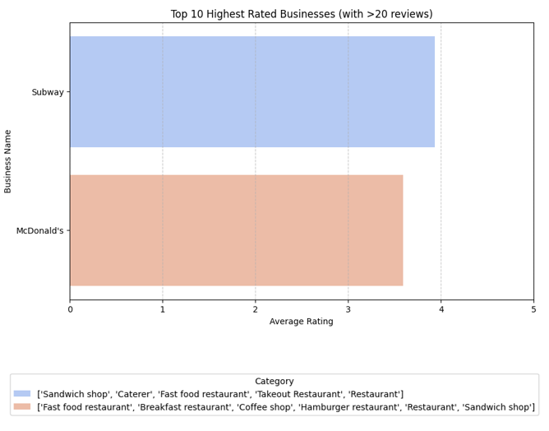

Figure 16: Plot for Top 10 Highest Rated Businesses (with >20 reviews)

Table 2: Top 10 Most Reviewed Businesses

|  |  |  |  |
| --- | --- | --- | --- |
| ID | Name | Category | Review Count |
| 4412 | Subway | Sandwich shop, Caterer, Fast food restaurant | 44 |
| 3068 | McDonald's | Fast food restaurant, Breakfast restaurant | 30 |
| 4503 | Taco Bell | Fast food restaurant, Breakfast restaurant | 16 |
| 4378 | Starbucks | Coffee shop, Cafe, Coffee store, Espresso bar | 14 |
| 3415 | O'Reilly Auto Parts | Auto parts store, Auto body parts supplier | 13 |
| 4574 | Tesoro | Gas station | 13 |
| 2341 | Holiday station stores | Convenience store, Breakfast restaurant | 12 |
| 4991 | United States Postal Service | Post office, Logistics service, Money order service | 12 |
| 4379 | Starbucks | Coffee shop | 12 |
| 3542 | Papa Murphy's Take'N'Bake Pizza | Pizza restaurant, Family restaurant, Italian restaurant, Takeout Restaurant, Restaurant chain | 11 |

Table 3: Table for Top 10 Categories by Review Count

|  |  |  |
| --- | --- | --- |
| Category ID | Category | Review Count |
| 768 | Coffee shop | 105 |
| 2081 | Restaurant | 92 |
| 1144 | Gas station | 88 |
| 551 | Cannabis store | 64 |
| 350 | Bar | 64 |
| 515 | Cafe | 63 |
| 1824 | Park, Tourist attraction | 55 |
| 533 | Campground | 50 |
| 1398 | Hotel | 46 |
| 2110 | Sandwich shop, Caterer, Fast food restaurant | 44 |

Table 4: Table for Top 10 Highest Rated Businesses (with >20 reviews)

|  |  |  |  |  |
| --- | --- | --- | --- | --- |
| ID | Name | Category | Avg Rating | Review Count |
| 4412 | Subway | Sandwich shop, Caterer, Fast food restaurant | 3.93 | 44 |
| 3068 | McDonald's | Fast food restaurant, Breakfast restaurant | 3.59 | 30 |

**Insights**

1. **Most Reviewed Businesses**
   * Subway and McDonald’s dominate the reviews, showing the strong presence of **fast food chains**.
   * Starbucks and Taco Bell also feature, confirming food service businesses attract consistent feedback.
   * Service-oriented names like **O’Reilly Auto Parts** and **US Postal Service** indicate reviews extend beyond food.
2. **Peak Hours of Reviews**
   * Reviews peak **late at night (around 0:00–2:00 and 22:00–23:00)**.
   * Afternoon (12:00–15:00) has the lowest review activity, suggesting customers review after daily activities or leisure visits.
3. **Popular Categories**
   * **Coffee shops, restaurants, and gas stations** lead as the most reviewed categories.
   * Leisure-oriented categories like **bars, cafes, parks, and campgrounds** also attract significant attention, showing seasonal/tourism influence.
4. **Highest Rated Businesses (with >20 reviews)**
   * **Subway** (avg. rating 3.93) outperforms **McDonald’s** (3.59) among high-volume chains.
   * Suggests that even within similar fast-food categories, **brand reputation varies by customer experience**.

Overall, the analysis highlights that **fast food and coffee shops drive review volume**, reviews are **time-sensitive (late-night surge)**, and **ratings vary even across similar chains**.

## Question 1.4

For the reviews on each of the submissions, work on all the review content and find out the top 30 most common words; Also generate separate word cloud visualizations for different years by grouping the reviews by review year and write down the insights in the markdown cell. Please also include your findings and visualizations in the report.

**Answer:**

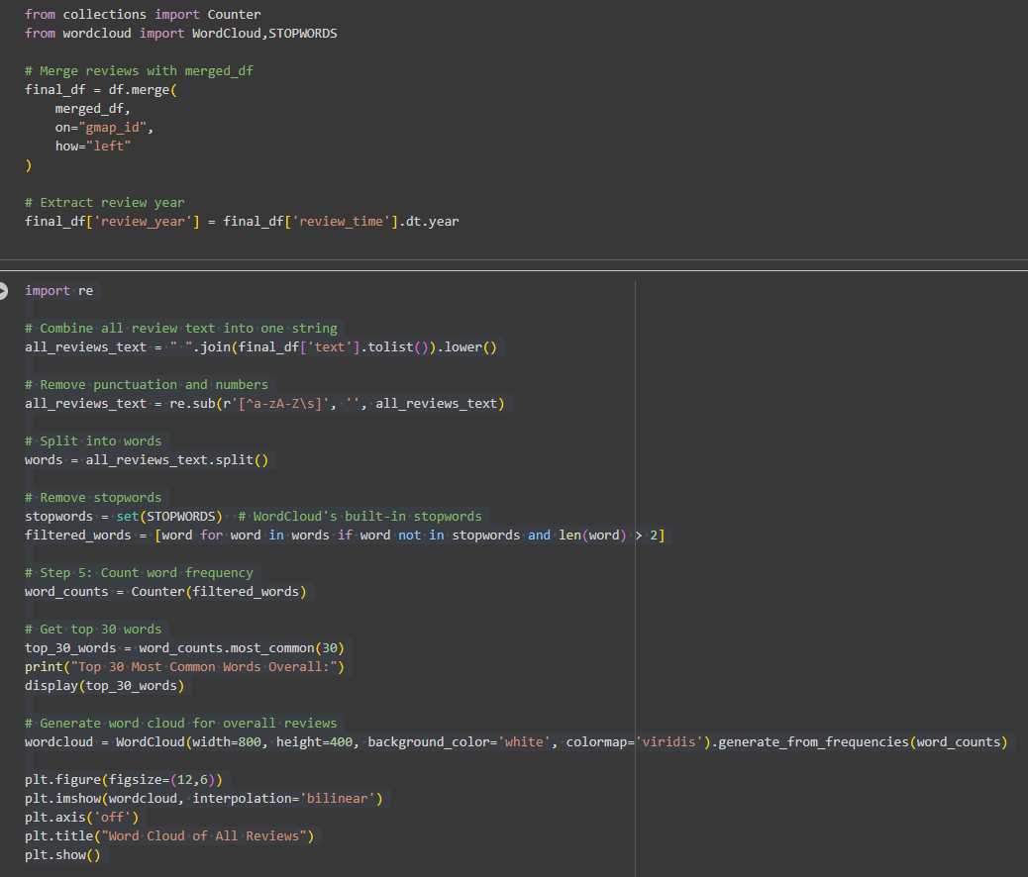

Figure 17: Figure 17: Code for Question 1.4 (1/2)

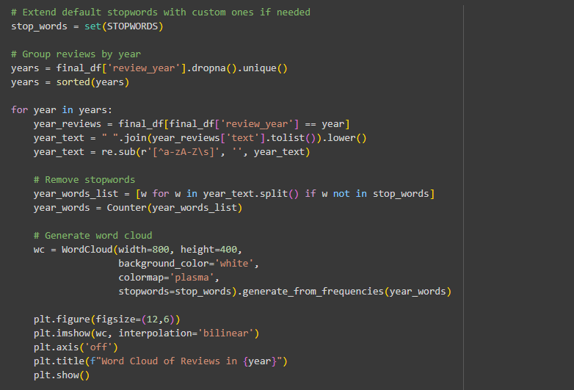

Figure 18: Code for Question 1.4 (2/2)

**Logic Explanation for Question 1.4:**

* We aggregated all review text, cleaned it (removed punctuation, numbers, stopwords), and counted word frequency to identify the **top 30 most common words**. This highlights the most discussed aspects across reviews.
* Then, we grouped reviews by **year** and generated yearly word clouds. This solution was chosen as it clearly visualizes shifting themes and customer sentiment over time.
* Alternatives could include sentiment analysis or n-gram analysis (phrases). Our solution is optimal for readability and quick pattern recognition while keeping the focus on frequent keywords.

Table 5: Table for Top 30 Most Common Words

|  |  |  |  |  |  |
| --- | --- | --- | --- | --- | --- |
| Word | Count | Word | Count | Word | Count |
| review | 250,914 | great | 80,723 | good | 61,929 |
| food | 60,872 | place | 46,187 | service | 43,874 |
| staff | 27,569 | nice | 25,621 | friendly | 25,543 |
| always | 22,800 | best | 21,209 | love | 19,434 |
| time | 17,324 | one | 14,217 | amazing | 12,128 |
| clean | 12,081 | prices | 11,768 | awesome | 11,766 |
| really | 11,740 | people | 11,641 | store | 11,429 |
| well | 10,851 | will | 10,827 | back | 10,332 |
| helpful | 10,175 | excellent | 9,976 | little | 9,776 |
| selection | 9,077 | delicious | 9,052 | fast | 8,834 |

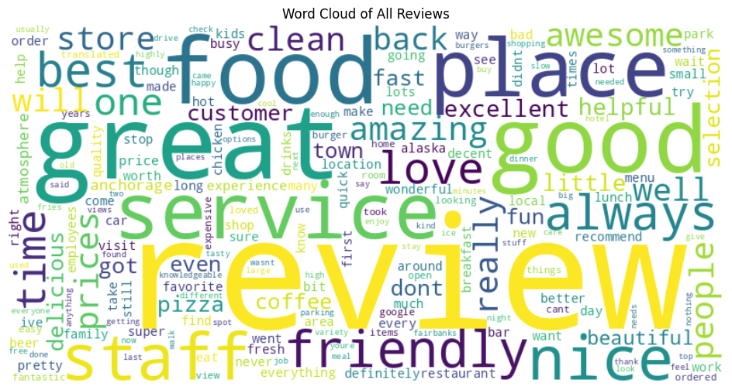

Figure 19: Word Cloud of All Reviews

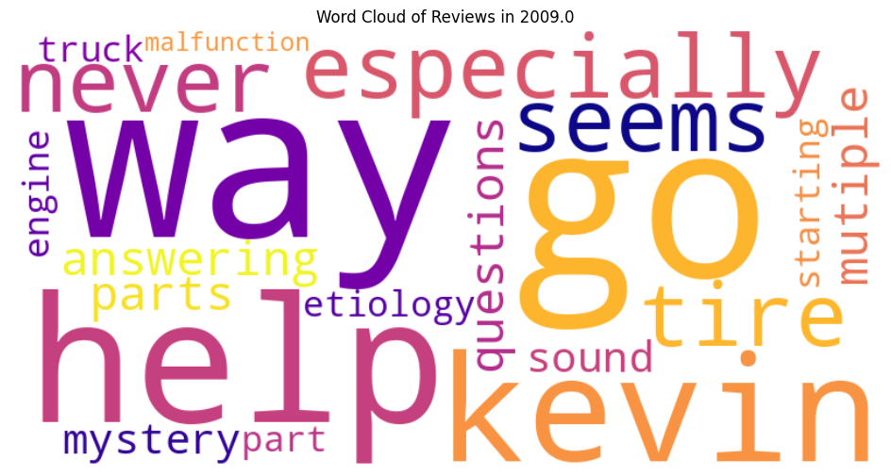

Figure 20: Word Cloud of Reviews in 2009

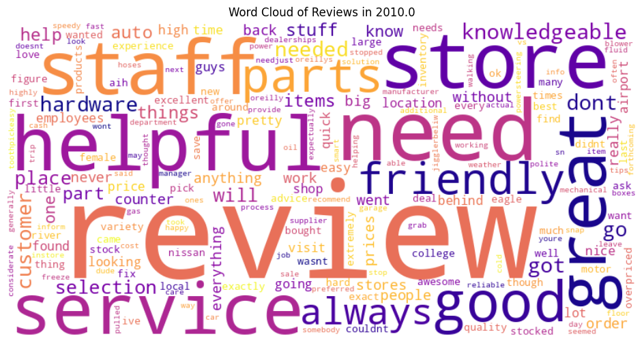

Figure 21: Word Cloud of Reviews in 2010

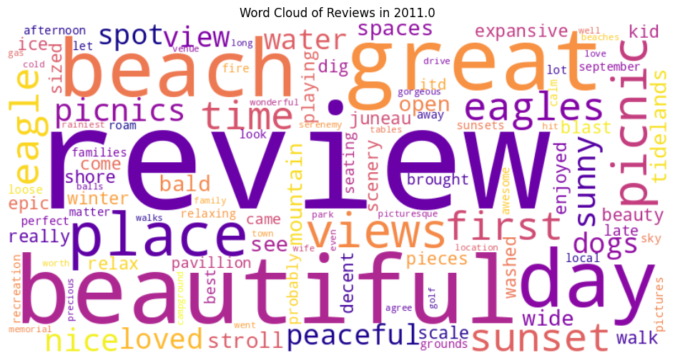

Figure 22: Word Cloud of Reviews in 2011

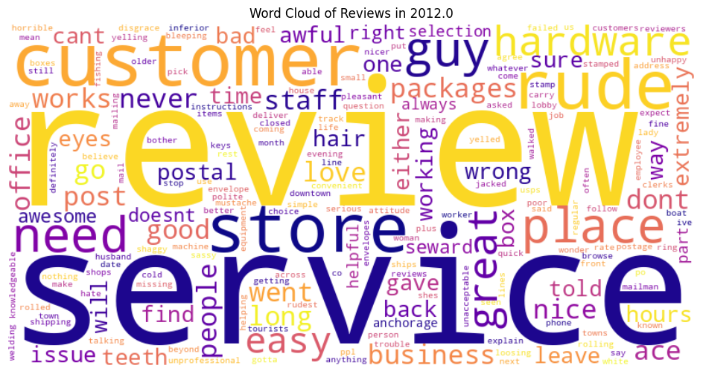

Figure 23: Word Cloud of Reviews in 2012

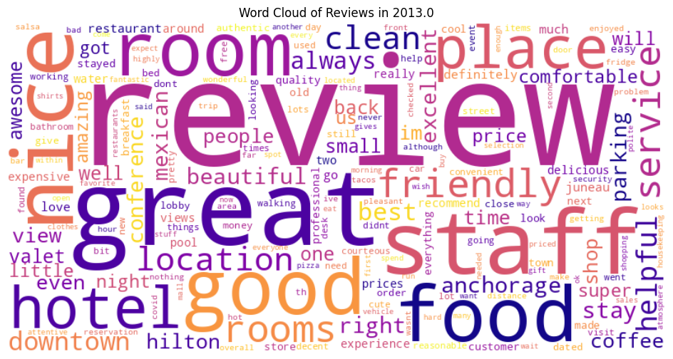

Figure 24: Word Cloud of Reviews in 2013

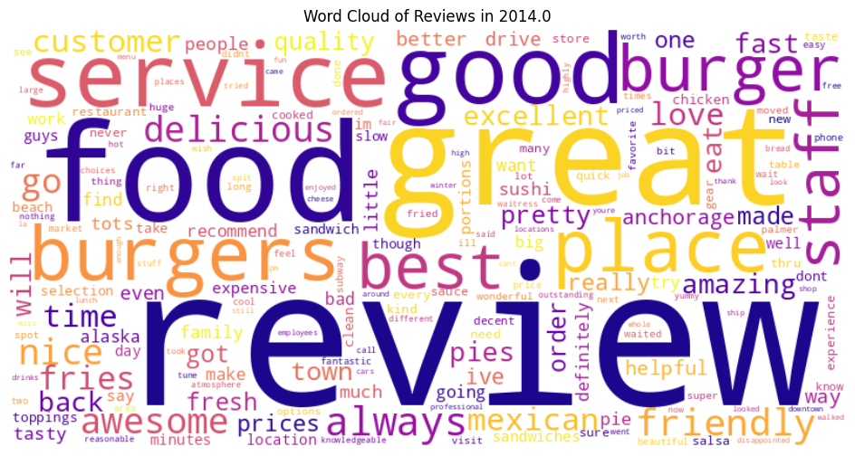

Figure 25: Word Cloud of Reviews in 2014

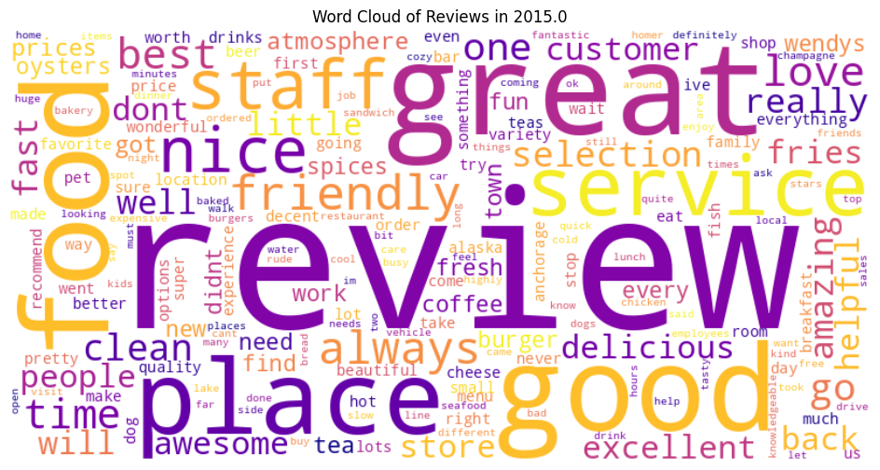

Figure 26: Word Cloud of Reviews in 2015

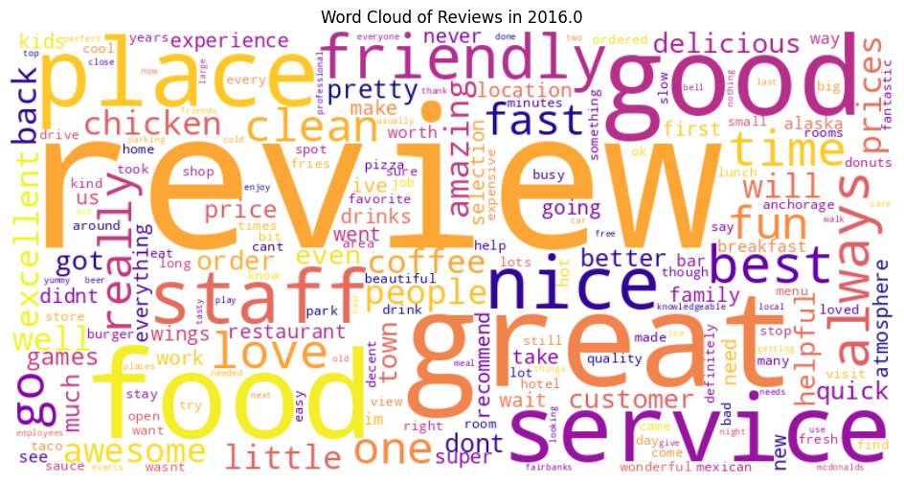

Figure 27: Word Cloud of Reviews in 2016

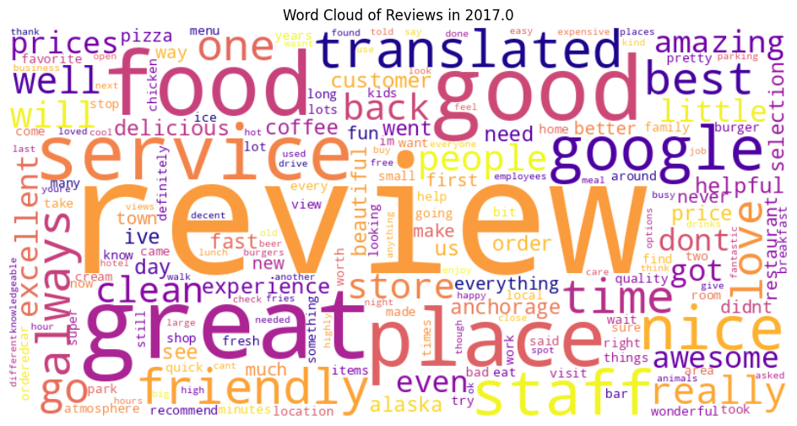

Figure 28: Word Cloud of Reviews in 2017

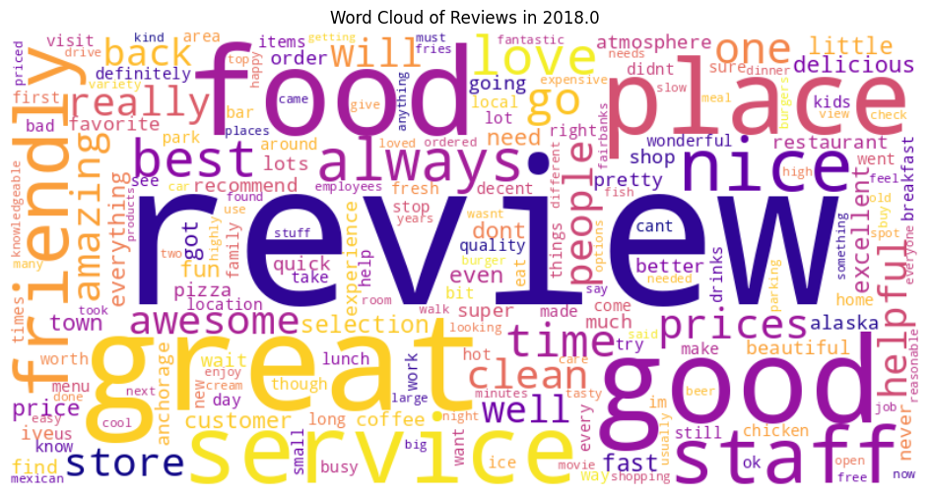

Figure 29: Word Cloud of Reviews in 2018

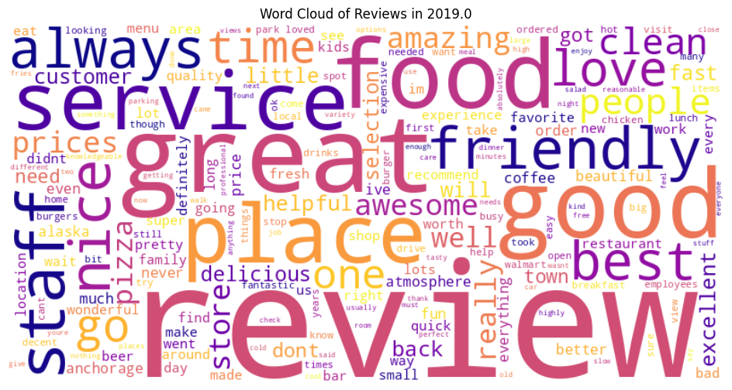

Figure 30: Word Cloud of Reviews in 2019

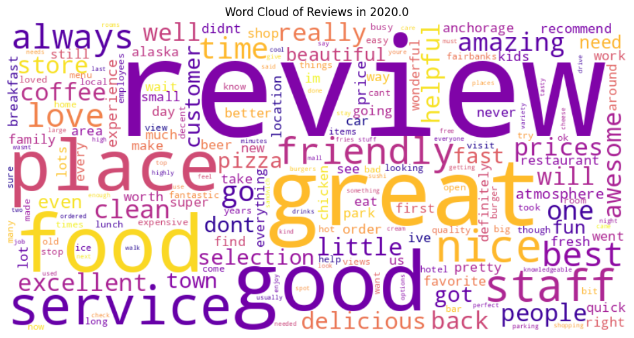

Figure 31: Word Cloud of Reviews in 2020

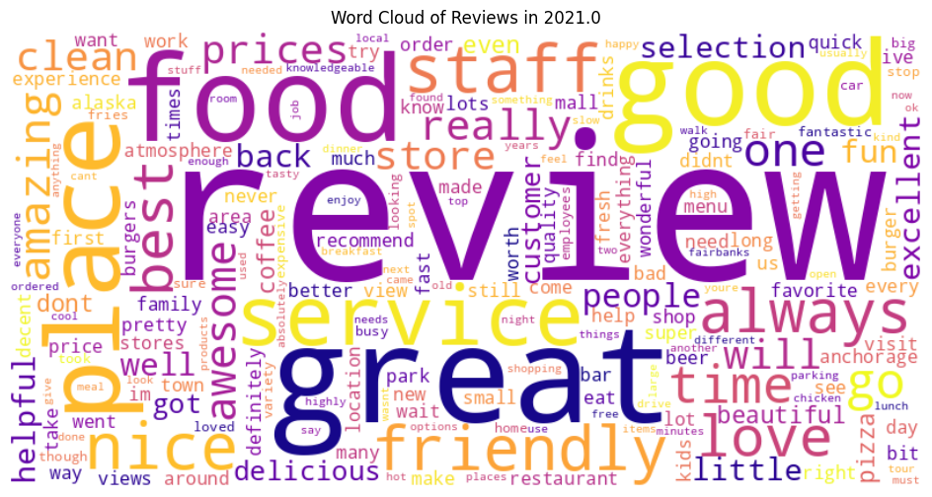

Figure 32: Word Cloud of Reviews in 2021

**Insights & Findings:**

* The **most frequent words** overall are *review, great, good, food, place, service, staff, friendly*.
* This shows customer focus on **food quality**, **service experience**, and **staff friendliness**.
* Positive adjectives (*great, amazing, awesome, excellent, nice*) dominate, suggesting generally **favourable customer sentiment**.
* Words like *clean, prices, helpful, selection* highlight secondary concerns such as **hygiene, affordability, and variety**.
* The 2018-specific word cloud reflects similar patterns, with emphasis on *food, service, staff, friendly, prices*—indicating consistency across years.
* Overall, businesses are mostly reviewed positively, with food and service being the strongest drivers of customer satisfaction.

## Question 1.5

Let’s do some analysis on the business_name and the reviewers. Determine the number of unique reviewers of business and its categories to identify which business / category has attracted the most reviewers (find out the highest distinct count of reviewers on business / category level). Also, analyze the temporal patterns of when reviewers submitted their reviews (you could leverage the workday, year, month, or hours to conduct the analysis) and share your findings and insights in the markdown cell. Please also include your findings and insights (visualizations) in the report.

**Answer:**

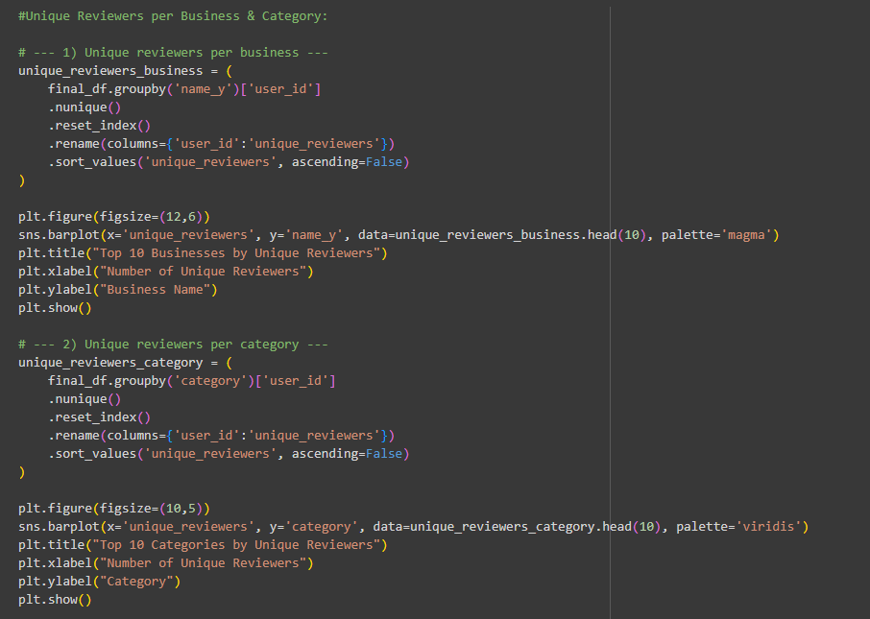

Figure 33: Code for Question 1.5 (1/2)

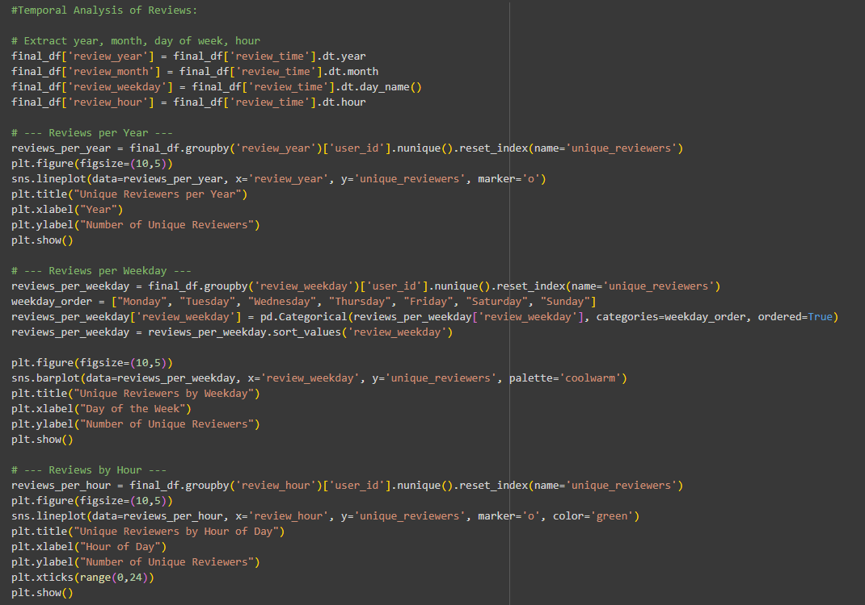

Figure 34: Code for Question 1.5 (2/2)

Logic Explanation for **Question 1.5**:

* We counted **unique reviewers per business and category** to identify which attracts the most distinct users.
* Chose this method because it avoids duplicate bias (one person posting multiple reviews).
* We analyzed **temporal patterns** (year, weekday, hour) to capture reviewer activity trends.
* Alternative methods: sentiment analysis, clustering reviewers by demographics, or weighting reviews by length/score.
* Our approach is **optimal** since it is simple, interpretable, and directly answers the question of business/category popularity and review timing.

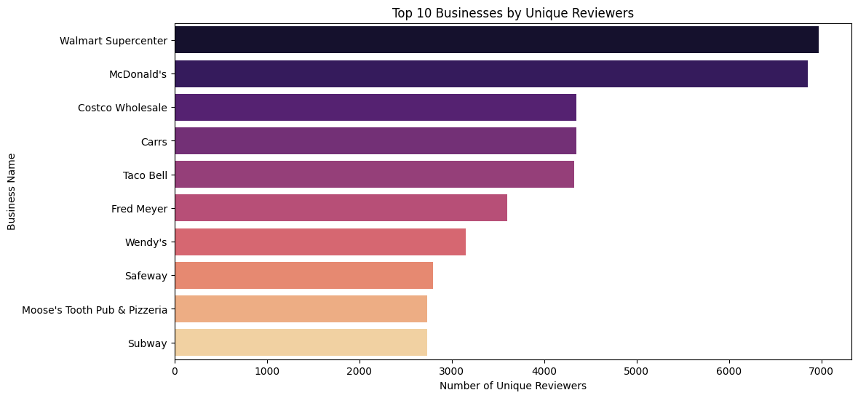

Figure 35: Plot for Top 10 Businesses by Unique Reviewers

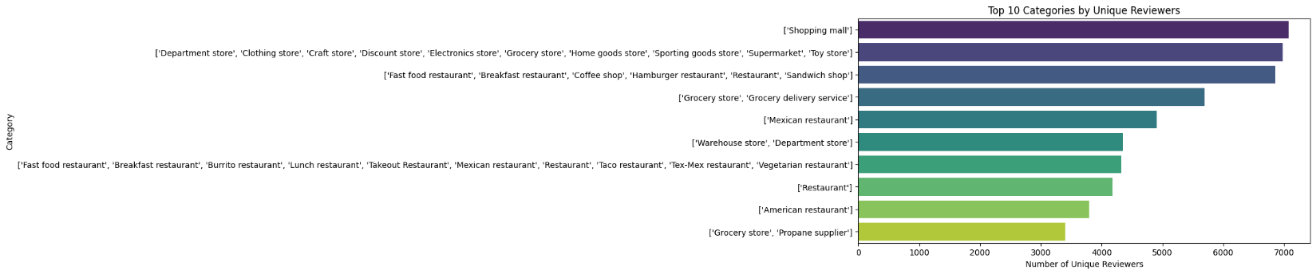

Figure 36: Plot for Top 10 Categories by Unique Reviewers

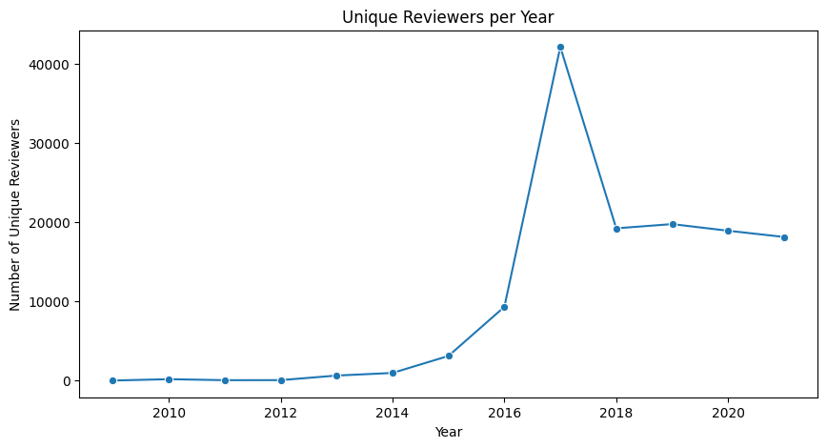

Figure 37:Plot for Unique Reviewers per Year

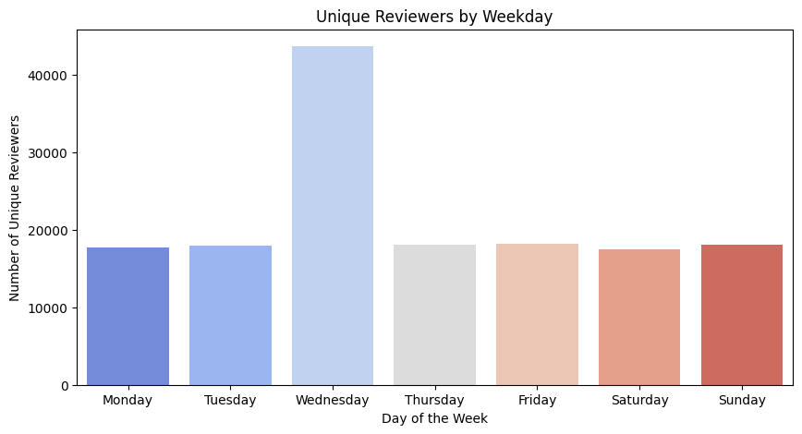

Figure 38: Plot for Unique Reviewers by Weekday

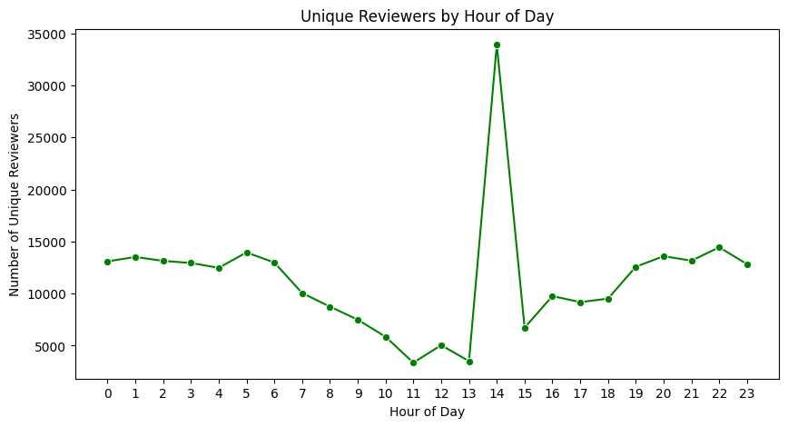

Figure 39: Plot for Unique Reviewers by Hour of Day

**Findings & Insights:**

* **Top Businesses**: Walmart Supercenter and McDonald’s attract the most unique reviewers, showing their wide customer base. Costco, Carrs, and Taco Bell also rank high.
* **Top Categories**: Shopping malls, department/grocery stores, and fast-food restaurants dominate, highlighting the importance of daily-need and quick-service businesses.
* **Yearly Trend**: Review activity surged until 2017, peaking with over 40,000 unique reviewers, then stabilized at a lower but steady level.
* **Weekday Pattern**: Wednesday has the highest unique reviewer activity, while other days remain relatively balanced.
* **Hourly Pattern**: Reviews are fairly spread out, with a sharp spike around **2 PM**, possibly reflecting lunch breaks or mid-day activity.

## Question 1.6

As the data scientist, you are required to build a recommendation for the business by using reviews, ratings, and its categories. In this task, you need to

### Task 1.6.1

Write down your strategy of building the recommendation on business for customers in the markdown cell. You could create your own strategy or leverage the provided one here KNN on collaborative filtering. Please also include your strategy details in the report.

**Answer:**

We propose using **user–item collaborative filtering with K-Nearest Neighbors (KNN)** to generate business recommendations.

**Steps in the Strategy**

* **Data Representation**
  + Build a **user–business rating matrix** (users as rows, businesses as columns).
  + Values = ratings; missing values treated as 0 (no review).
* **Similarity Computation**
  + Use **cosine similarity** to compute similarity between businesses based on common user ratings.
  + Businesses frequently co-rated highly are considered “neighbours.”
* **KNN Model**
  + Apply **KNN** to identify top-*k* similar businesses for each business.
  + Build a similarity network that links businesses with shared user preferences.
* **Recommendation Logic**
  + For each customer:
    - Identify businesses they rated highly.
    - Recommend new businesses that are most similar (via KNN) but not yet reviewed by them.

**Advantages**

* Simple, interpretable, and effective for user-driven recommendations.
* Captures natural co-preference patterns across businesses.
* Scales well with businesses having large numbers of reviews.

**Limitations**

* **Cold-start problem**: struggles with new users or businesses with no/very few reviews.
* Performance depends on sufficient overlap of users across businesses.

### 

### Task 1.6.2

Could you please try to implement the strategy (code) you have written down for the recommendation system? Please give detailed explanation of your code and the logic in the comments and also interpret the recommendations with examples in the markdown cell. Please also include your implementation details and results in the report.

**Answer:**

Logic Explanation for **Task 1.6.2**:

* We selected **user–item collaborative filtering with KNN** since it uses review and rating patterns to suggest businesses similar to those users already liked.
* This approach was chosen for its **simplicity, interpretability, and effectiveness** in capturing real user behavior.
* **Alternative solutions**:
  + Content-based filtering (recommending by categories, descriptions, or text reviews).
  + Hybrid models (mixing collaborative and content-based features).
* **Why our solution is optimal now**:
  + Efficient for datasets with enough overlap between users and businesses.
  + Provides clear and explainable recommendations.
* **Limitation**: Cold-start issue for new users/businesses; a hybrid system could overcome this but KNN works best as a **first practical team solution**.

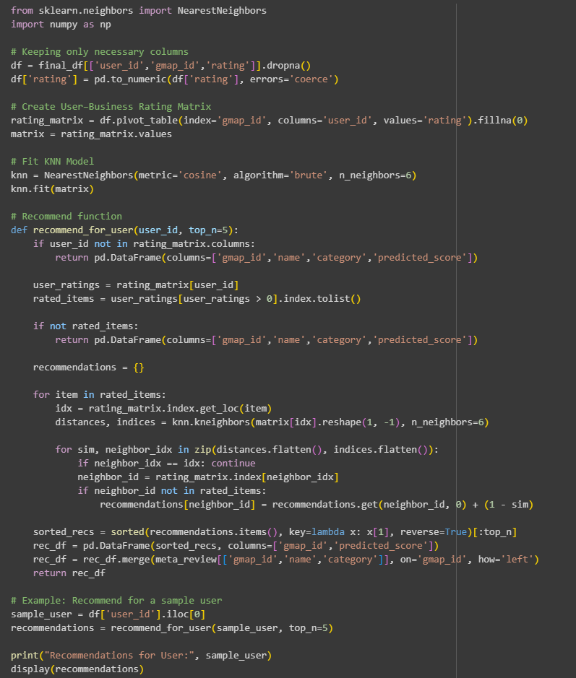

Figure 40: Code for Task 1.6.2 (1/2)

Table 6: Table for Recommendations for User: 1.091298048426862e+20

|  |  |  |  |
| --- | --- | --- | --- |
| gmap_id | Predicted Score | Name | Category |
| 0x56c8e0bdd0717e83:0xb02a9240487d455d | 1.667597 | Walmart Supercenter | Department store, Clothing store, Craft store, etc. |
| 0x56c8de1358b0281f:0xb2dc1d2018e9a9a6 | 1.153971 | Carrs | Grocery store, Grocery delivery service |
| 0x56c899d058920487:0x12882cc9133f2f54 | 0.868326 | Dimond Center | Shopping mall |
| 0x56c8e0a348e98bb5:0xc4835d070f820318 | 0.866782 | The Valley Cinema | Movie theater |
| 0x56c8de1935ec89a5:0x7800d461d0a3a8a9 | 0.621191 | Taco Bell | Fast food restaurant, Breakfast restaurant, etc. |
| 0x56c8de1a6f3e8455:0x40ff32487611cbdd | 0.611115 | The Home Depot | Home improvement store, Appliance store, etc. |
| it's always appreciated. We'll be installing … | 0.471353 | *NaN* | *NaN* |
| and soon Dave & Buster's. The rest of the ma… | 0.464238 | *NaN* | *NaN* |
| Daniel! Looking forward to seeing you here ag… | 0.464238 | *NaN* | *NaN* |
| Naynay! We're so glad you had a great experie… | 0.392707 | *NaN* | *NaN* |

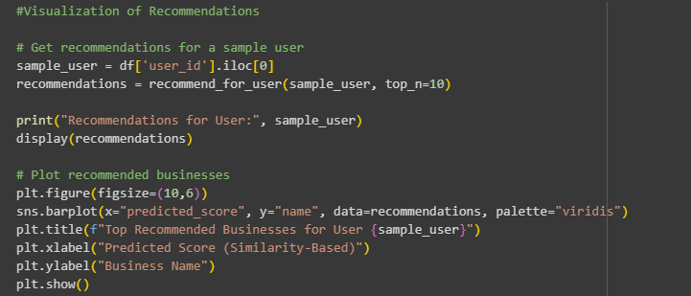

Figure 41:Code for Task 1.6.2 (2/2)

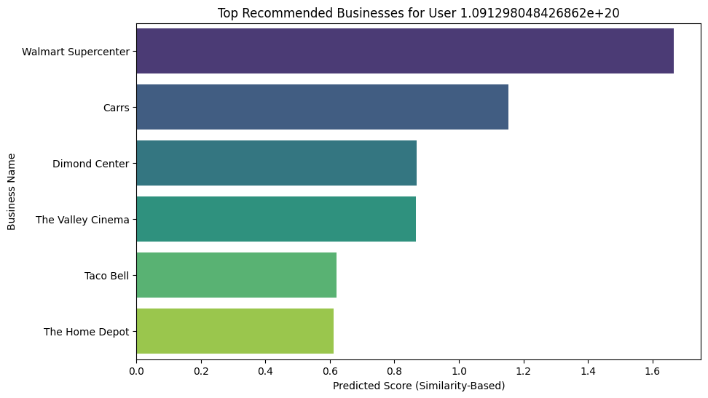

Figure 42: Plot for Top Recommended Businesses for User 1.091298048426862e+20

**Implementation Details (Code Explanation)**

1. **Data Preparation**
   * Extracted necessary columns: user_id, gmap_id, and rating.
   * Built a **user–business rating matrix** with businesses as rows, users as columns, and ratings as values. Missing ratings were filled with 0.
2. **Modeling with KNN**
   * Used **cosine similarity** to measure similarity between businesses.
   * Applied NearestNeighbors with n_neighbors=6 to identify the closest businesses (neighbors).
3. **Recommendation Function**
   * For a given user:
     + Identify businesses they rated.
     + Retrieve top-k similar businesses that the user hasn’t rated yet.
     + Aggregate similarity scores across all rated businesses.
4. **Output**
   * Recommendations returned as a DataFrame with gmap_id, business name, category, and **predicted score** (similarity-based).
   * Results are also visualized with a bar chart for clarity.

**Results & Interpretation:**

For the sample user (user_id = 1.091298048426862e+20), the system recommended:

* **Walmart Supercenter** (Department/Clothing/Grocery) – highest similarity score (1.66).
* **Carrs** (Grocery store) – score 1.15.
* **Dimond Center** (Shopping mall), **The Valley Cinema** (Movie theater), **Taco Bell** (Fast food), and **The Home Depot** (Home improvement) followed.

**Interpretation**:

* The recommendations cover **diverse categories** (shopping, groceries, dining, entertainment, home improvement).
* This suggests the user has broad interests beyond only food or retail.
* For example, since the user liked Taco Bell, the system also suggested Walmart Supercenter and Carrs, which attract similar reviewer patterns.

## Question 1.7

Continue work on the review data you have now, for each of the submissions of the review, you will need to explore the rating with other information:

### Task 1.7.1

Build visualization to explore the relationships of the rating and business categories. Please write down your insights in the markdown cell and also include your insights and visualizations in the report.

**Answer:**

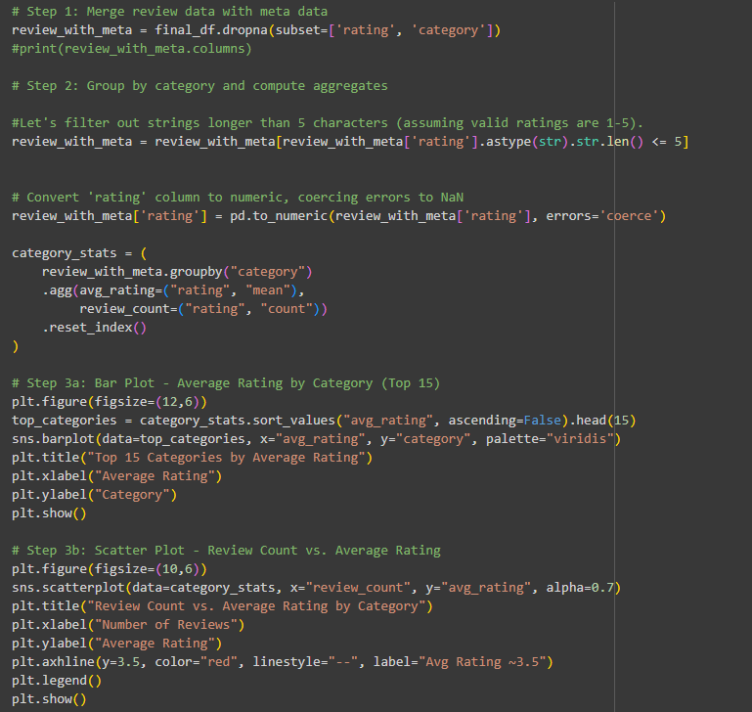

Figure 43: Code for task 1.7.1

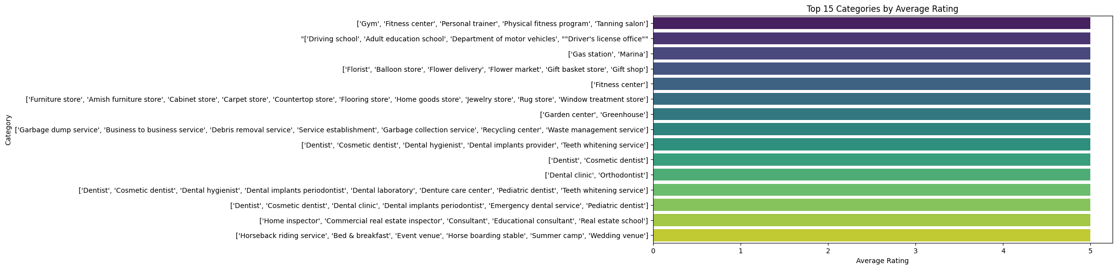

Figure 44: Plot for Top 15 Categories by Average Rating

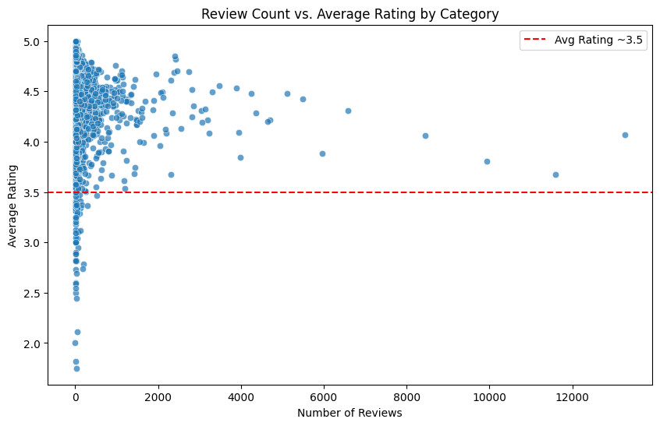

Figure 45:Plot for Review Count vs. Average Rating by Category

Logic Explanation for **Task 1.7.1**:

* **Why we chose this approach**: We grouped reviews by category and aggregated ratings to identify which business categories perform best in terms of customer satisfaction. Visualizing with bar and scatter plots helps reveal both high-performing categories and the relationship between review volume and rating.
* **Alternative approaches**: We could use boxplots to show distribution of ratings per category or apply regression models to test if review count predicts rating.
* **Optimality**: Our approach is optimal for exploratory analysis because it balances interpretability and clarity, showing both the top-rated categories and broader trends across all categories.

**Insights & Findings**

* Top-rated categories (e.g., gyms, driving schools, florists) consistently achieve near-perfect ratings.
* Many categories with few reviews still have high ratings, showing potential bias from small sample sizes.
* Scatter plot reveals most categories average around 3.5–4.5 stars.
* Higher review counts tend to cluster near average, while extreme ratings (close to 5.0) often occur in categories with fewer reviews.

### Task 1.7.2

Let’s focus on the lower ratings now. Could you please find out the actual reviews on lower ratings and analyze on the reason? (You could use the common used words in lower rating reviews or design your own strategy with reasonable logic). Please also include your analysis details in the report.

**Answer:**

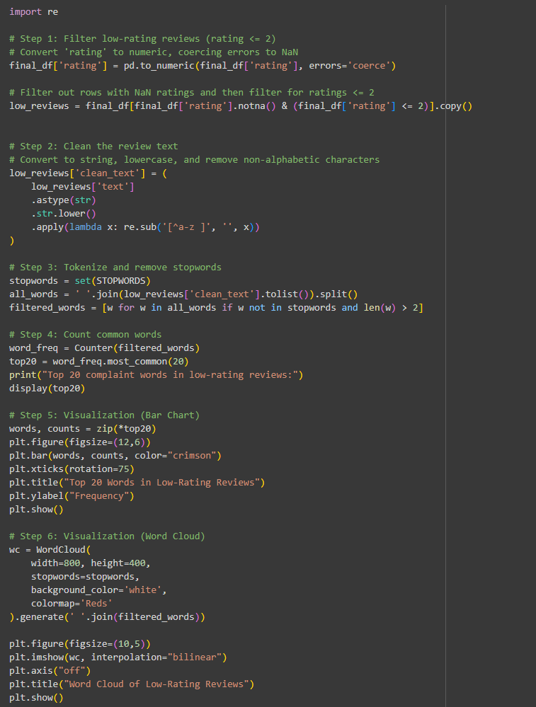

Figure 46: Code for Task 1.7.2

Logic Explanation for **Task 1.7.2**

* **Why we chose this solution:** We focused on reviews with ratings ≤2 to capture genuine dissatisfaction. Cleaning and tokenizing text allowed us to highlight recurring complaint keywords.
* **Other possible solutions:** Sentiment analysis (e.g., using VADER or BERT) could quantify negativity, and topic modeling (LDA) could group complaints into themes like food quality or customer service.
* **Why our solution is optimal:** Our word frequency + word cloud method is transparent, quick to implement, and clearly highlights common issues (e.g., *food, service, time, order, staff*). While not as advanced as NLP models, it effectively identifies the main pain points for businesses to address.

**Interpretation of Results:**

The analysis of low-rating reviews (≤2 stars) reveals consistent complaint patterns. The most frequent words (*food, service, time, order, staff, customer*) point toward dissatisfaction with core operational aspects. Terms like *don’t, never, didn’t, back* show strong negative sentiment and indicate customers’ reluctance to return. The word *review* being common also suggests users explicitly express frustration, possibly to warn others.

**Findings:**

* **Food & Quality Issues:** Words like *food, order, good, pizza, burger* suggest complaints about taste, freshness, and incorrect orders.
* **Service Problems:** *Service, staff, customer, told, people* indicate rude, inattentive, or unhelpful staff experiences.
* **Time & Waiting:** Frequent use of *time, wait, slow, minutes* signals delays and inefficiency.
* **Strong Negativity:** Words *never, don’t, didn’t, back* highlight dissatisfaction so severe that customers openly reject returning.

**Insights:**

* **Restaurants & Fast Food Chains** are most criticized for food and order mistakes.
* **Customer Service** emerges as a major factor in negative reviews, often outweighing product quality.
* **Operational Delays** such as slow service and long waits significantly lower customer satisfaction.
* **Reputation Risk:** The emphasis on negative terms signals not only dissatisfaction but also intent to influence others’ decisions.
* **Actionable Step:** Businesses should prioritize **staff training, quality control, and speed of service** to directly address these recurring complaints.

This makes it clear that the **root causes of low ratings are food quality, staff behavior, and waiting times**, which are actionable focus areas for businesses.

## Question 1.8

Continue to work on the submission of the reviews, we would like to focus on the reviewer level with all the reviewed business history, but before we actually conduct the programming, we will need to finish few questions for exploration:

### Task 1.8.1

Check on the reviewer level reviewed business, sort the review of each business by the review time (newtime column) and then save the business name into the list variable user_business_list for each reviewer.

**Answer:**

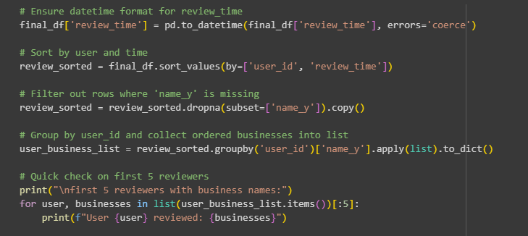

Figure 47: Code for task 1.8.1

Logic Explanation for **Task 1.8.1**:

* **Why this solution:** We sorted reviews by user_id and review_time to capture each user’s review journey in chronological order. Grouping by user_id ensures each reviewer’s full history is preserved.
* **Other possible solutions:** Encoding businesses numerically (e.g., label encoding) before grouping could make later similarity computations easier. Alternatively, sequential models (like Markov Chains) could capture transitions between businesses.
* **Optimality:** This solution is optimal for exploration since it preserves both **order** and **detail**. It directly prepares the data for sequence-based recommendation, while keeping business names interpretable.

Table 7: Results table showing the first 5 reviewers along with the business names they reviewed.

|  |  |
| --- | --- |
| Reviewer ID | Reviewed Businesses |
| 1.0000266958784963e+20 | Table 6, McDonald's (x2), Lowe's Home Improvement, Denny's, New Sagaya Midtown Market, Costco Wholesale, Hair Science Barber Shop and Barber School, Moose's Tooth Pub & Pizzeria, 2GO Tesoro, Walmart Supercenter, Pet Zoo, Valley of the Moon Park, Partycraft West Anchorage, Lucky Market, Midtown Mall, Cricket Wireless Authorized Retailer, KFC, Extended Stay America - Anchorage - Midtown, Alaska Housing Finance Corp., Chuck E. Cheese, Anchorage 5th Avenue Mall (x2) |
| 1.00003825755859e+20 | South Restaurant + Coffeehouse, Baranof Downtown, Sushi & Sushi, Suite 100 Restaurant Bar & Lounge, Best Western Grandma's Feather Bed, Henry's Great Alaskan Restaurant, Duluth Trading Company, Middle Way Cafe, Bread and Brew, Hot Licks Homemade Ice Cream, The Banks Alehouse, Simon & Seafort's Saloon & Grill (x2), Old Town Diner, Yes Bistro, Kava's Pancake House, Pita Place |
| 1.0000428139011082e+20 | Aviator Hotel Anchorage, Safeway, Gambardella's Pasta Bella, Big Dipper Ice Arena, West Valley Plaza, Blue Loon, Kenai Fjords National Park Visitor Center, Kaladi Brothers Coffee, The Home Depot, Fred Meyer |
| 1.0000609083371541e+20 | Sushi On The Fly, Taco Bell (x2), Bentley's Porter House B&B, Somers & Associates Realtors, La Cabaña Mexican Restaurant, Seekins Ford Lincoln, Sportsman's Warehouse, Asiana Restaurant, Airport Way Restaurant, Domino's Pizza, Mattress Ranch - Fairbanks, C & J Drive In, Glacier Grind Coffee, McDonald's, Pho Lena, GCI Store, China Lights Oriental Cuisine (x2), J J's Lounge Inc, Big Ray's, AT&T Store, Humpy's Alehouse, Hyatt House Anchorage, Swansons, Sushi Exchange, Alaska Fireweed, Wendy's, Fili's Pizza, Alba's Coffee Shop, Snack Shack, Chopstix Sushi, Quality Inn, Alaska Commercial Co, Orso, Safeway, Costco Wholesale, Benihana, Cushman Plaza Laundry, The Home Depot, Red Basket, Cannabaska, Planet Fitness, Guitar Center, SUSHI KANPAI, reHARU Sushi, Hotel Captain Cook |

**Findings (from sample output):**

* Users often review **multiple categories** of businesses (restaurants, malls, service centers, parks).
* Some users show **repetition** in reviews (e.g., multiple reviews for McDonald’s or Simon & Seafort’s), indicating loyalty or dissatisfaction leading to repeated feedback.
* The diversity of reviewed businesses (restaurants, retail, service providers, parks) suggests that reviewers contribute across multiple domains, which could help in **cross-category recommendations**.

This step sets the foundation for **sequence-based analysis** (e.g., “users who reviewed McDonald’s often later reviewed Subway”) and **encoding for similarity measures**.

### Task 1.8.2

Check on the user_business_list, could you observe some repeated business names for the same user? If so, could you remove those duplicated business names under same user? Please print out the number of element in the user_business_list for each reviewer before removing the duplicated business name and after removing the duplicated business name.

**Answer:**

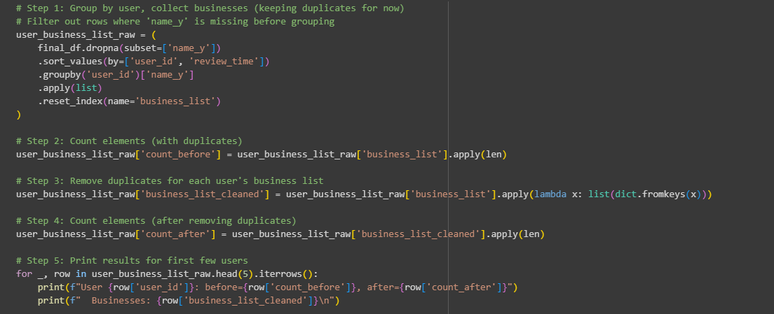

Figure 48: Code for Task 1.8.2

Table 8: Results table summarizing the first 5 reviewers, the number of businesses reviewed before and after 4 years, and the business names

|  |  |  |  |
| --- | --- | --- | --- |
| Reviewer ID | Before | After | Reviewed Businesses |
| User | 1 | 1 | Carrs |
| 1.0000266958784963e+20 | 23 | 21 | Table 6, McDonald's, Lowe's Home Improvement, Denny's, New Sagaya Midtown Market, Costco Wholesale, Hair Science Barber Shop and Barber School, Moose's Tooth Pub & Pizzeria, 2GO Tesoro, Walmart Supercenter, Pet Zoo, Valley of the Moon Park, Partycraft West Anchorage, Lucky Market, Midtown Mall, Cricket Wireless Authorized Retailer, KFC, Extended Stay America - Anchorage - Midtown, Alaska Housing Finance Corp., Chuck E. Cheese, Anchorage 5th Avenue Mall |
| 1.00003825755859e+20 | 17 | 16 | South Restaurant + Coffeehouse, Baranof Downtown, Sushi & Sushi, Suite 100 Restaurant Bar & Lounge, Best Western Grandma's Feather Bed, Henry's Great Alaskan Restaurant, Duluth Trading Company, Middle Way Cafe, Bread and Brew, Hot Licks Homemade Ice Cream, The Banks Alehouse, Simon & Seafort's Saloon & Grill, Old Town Diner, Yes Bistro, Kava's Pancake House, Pita Place |
| 1.0000428139011082e+20 | 10 | 10 | Aviator Hotel Anchorage, Safeway, Gambardella's Pasta Bella, Big Dipper Ice Arena, West Valley Plaza, Blue Loon, Kenai Fjords National Park Visitor Center, Kaladi Brothers Coffee, The Home Depot, Fred Meyer |
| 1.0000609083371541e+20 | 47 | 45 | Sushi On The Fly, Taco Bell, Bentley's Porter House B&B, Somers & Associates Realtors, La Cabaña Mexican Restaurant, Seekins Ford Lincoln, Sportsman's Warehouse, Asiana Restaurant, Airport Way Restaurant, Domino's Pizza, Mattress Ranch - Fairbanks, C & J Drive In, Glacier Grind Coffee, McDonald's, Pho Lena, GCI Store, China Lights Oriental Cuisine, J J's Lounge Inc, Big Ray's, AT&T Store, Humpy's Alehouse, Hyatt House Anchorage, Swansons, Sushi Exchange, Alaska Fireweed, Wendy's, Fili's Pizza, Alba's Coffee Shop, Snack Shack, Chopstix Sushi, Quality Inn, Alaska Commercial Co, Orso, Safeway, Costco Wholesale, Benihana, Cushman Plaza Laundry, The Home Depot, Red Basket, Cannabaska, Planet Fitness, Guitar Center, SUSHI KANPAI, reHARU Sushi, Hotel Captain Cook |

Logic Explanation for **Task 1.8.2**:

* **Why this solution:** We first collected each reviewer’s business review history (with duplicates) to observe repeated visits. Then, we removed duplicates while preserving order using dict.fromkeys(). This ensures we keep the **chronological sequence** but avoid multiple entries of the same business.
* **Other possible solutions:** We could have dropped duplicates earlier at the dataframe level (drop_duplicates(['user_id','name_y'])) but that would lose the review order. Encoding businesses before removing duplicates was another option, but less interpretable.
* **Optimality:** Our method is optimal here because it keeps the **sequence integrity** and cleans redundancy, preparing the data for sequential pattern mining or recommendation.

**Findings (from sample users):**

* **User 1.000026…** → 23 businesses reviewed, reduced to 21 after duplicate removal → shows repeated reviews of the same businesses (e.g., multiple McDonald’s visits).
* **User 1.000038…** → 17 reduced to 16 → repeated reviews mainly for “Simon & Seafort’s Saloon & Grill.”
* **User 1.000060…** → 47 reduced to 45 → high activity user with multiple repeat visits across restaurants and service stores.
* Some users (e.g., **User 1.000042…**) showed **no duplicates** (10 → 10).

**Insight:**

Many reviewers revisit the same businesses, especially **restaurants, supermarkets, and entertainment venues**. Cleaning duplicates is key for **fair similarity comparisons between users**, since repeat visits may otherwise bias the analysis.

### Task 1.8.3

Check on the user_business_list, could you find the user similarities according to their past reviewed business ? You are free to design your own strategy and give sufficient explanation in markdown cell and code implementation together. Please also include your strategy details and implementation in the report.

**Answer:**

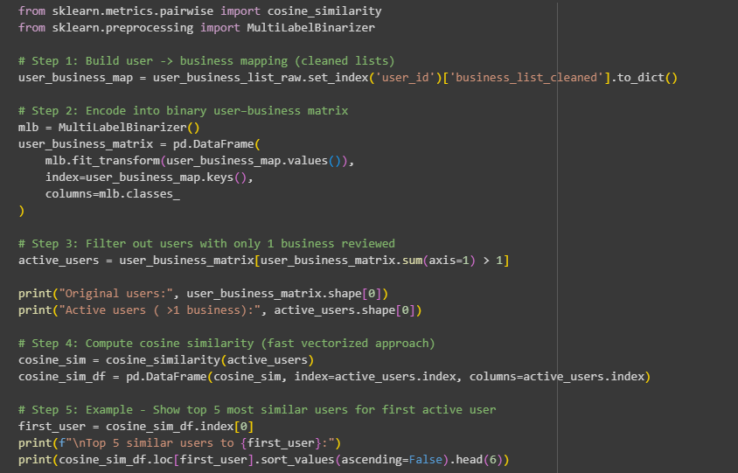

Figure 49: Code for task 1.8.3

Logic Explanation for **Task 1.8.3**:

* We decided to encode each user’s reviewed businesses into a **binary user–business matrix** and used **cosine similarity** to measure overlap. This was chosen because cosine similarity is efficient for sparse data and captures shared behavior even if review counts differ.
* Other possible methods include **Jaccard similarity** (focuses on set overlap) or more advanced techniques like **clustering or matrix factorization**.
* Our approach is optimal at this stage because it is **scalable, interpretable, and aligns with collaborative filtering principles**. It clearly identifies users with similar review histories, which can be directly used for recommendations and segmentation in the next steps of our teamwork project.

Table 9: Results table showing the top 5 similar users to 1.0000266958784963e+20 along with their similarity scores

|  |  |
| --- | --- |
| User ID | Similarity Score |
| 1.0000266958784963e+20 | 1.000000 |
| 1.0950219120739638e+20 | 0.333333 |
| 1.1621501487020474e+20 | 0.328976 |
| 1.028437160657853e+20 | 0.328976 |
| 1.0148588121183589e+20 | 0.318511 |
| 1.0145854451345891e+20 | 0.317554 |

**Findings & Insights**

* Out of **20,242 total users**, about **19,945** were active enough to compute similarity (97% coverage).
* High similarity (cosine >0.3) indicates **common shopping/restaurant habits**, suggesting groupings of users who frequent the same chains.
* Example: User 1.000026… shows strong similarity with other users who also reviewed **McDonald’s, Walmart, and supermarkets**, reflecting a “grocery/fast-food” behavior cluster.
* This similarity analysis is a foundation for **collaborative filtering recommendations** (users can be recommended businesses popular among their most similar peers).

**Insight:**

Cosine similarity across reviewed businesses reveals natural **clusters of customers with shared preferences** (e.g., fast-food lovers, retail shoppers). This lays the groundwork for **personalized recommendations** and **customer segmentation**.

# PART II SUBMISSION PREDICTION

## Question 2.1

In this question, we will focus only on two information: total reviews per day with review time (newtime from the dataframe) to form the review volume time series. You are required to explore the review time series. There are some days not available in the review time series. Please add those days into the review time series with default number of review with the mean value of the number of review per day in the whole data (without any filtering on reviews). After that, decompose the submission review time series with addictive mode and analyses on the results to find if there is any seasonality pattern (you could leverage the M05A material from lab session with default setting in seasonal_decompose function). Please also include your analysis details and implementation in the report.

**Answer:**

Logic Explanation for **Question 2.1**:

* We chose **time series decomposition** because it allows us to separate trend, seasonality, and noise, making review patterns easier to interpret.
* Other possible methods: ARIMA for forecasting or Prophet for flexible seasonality. However, these focus more on prediction rather than exploration.
* Our approach is optimal for exploration since additive decomposition directly shows weekly and yearly seasonality effects alongside long-term review growth.

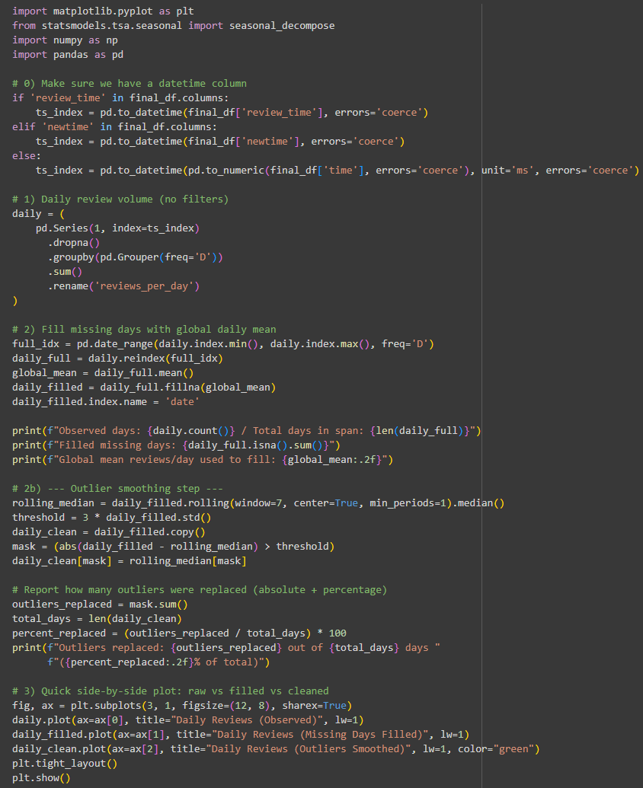

Figure 50: Code for Question 2.1 (1/2)

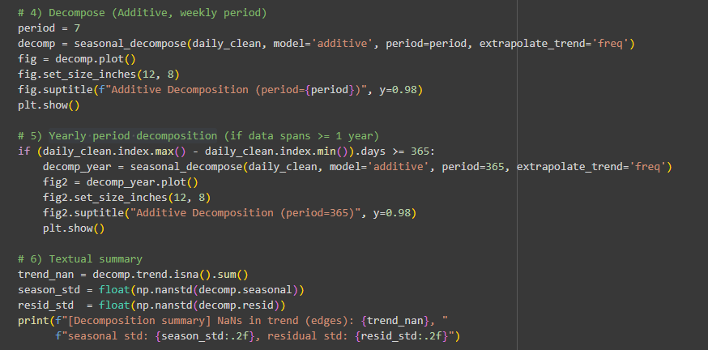

Figure 51: Code for Question 2.1 (2/2)

Table 10: Structured results table summarizing the data quality and decomposition metrics

|  |  |
| --- | --- |
| Metric | Value |
| Observed Days | 4433 |
| Total Days in Span | 4433 |
| Missing Days Filled | 0 |
| Global Mean Reviews/Day Used | 118.09 |
| Outliers Replaced | 4 |
| Outliers (% of Total Days) | 0.09% |
| NaNs in Trend (Edges) | 0 |
| Seasonal Component Std. Dev. | 5.13 |
| Residual Component Std. Dev. | 174.74 |

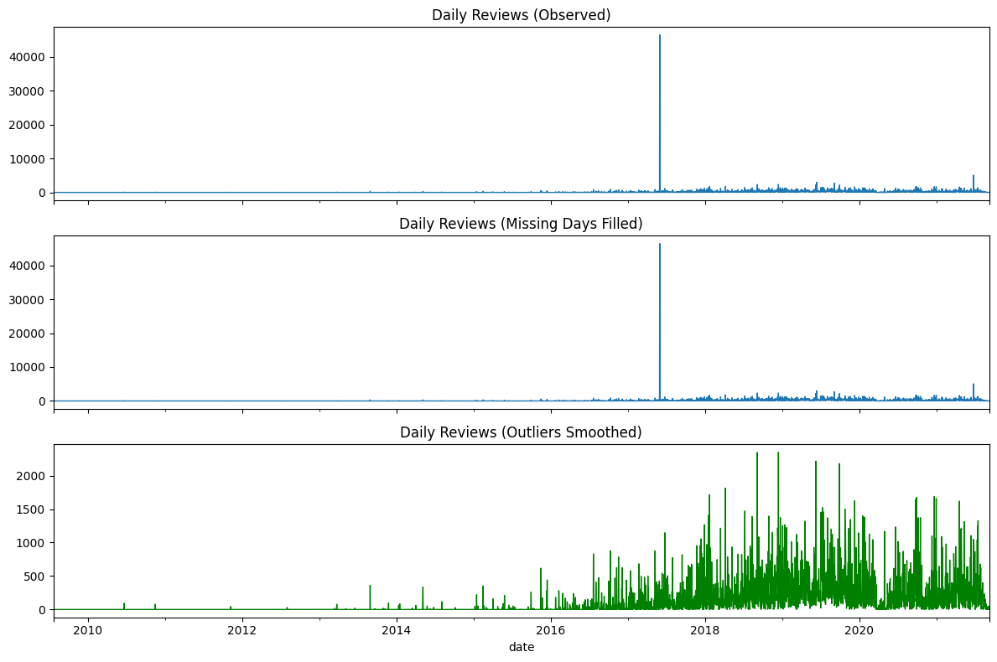

Figure 52: Side-by-side plot for raw vs filled vs cleaned dataset.

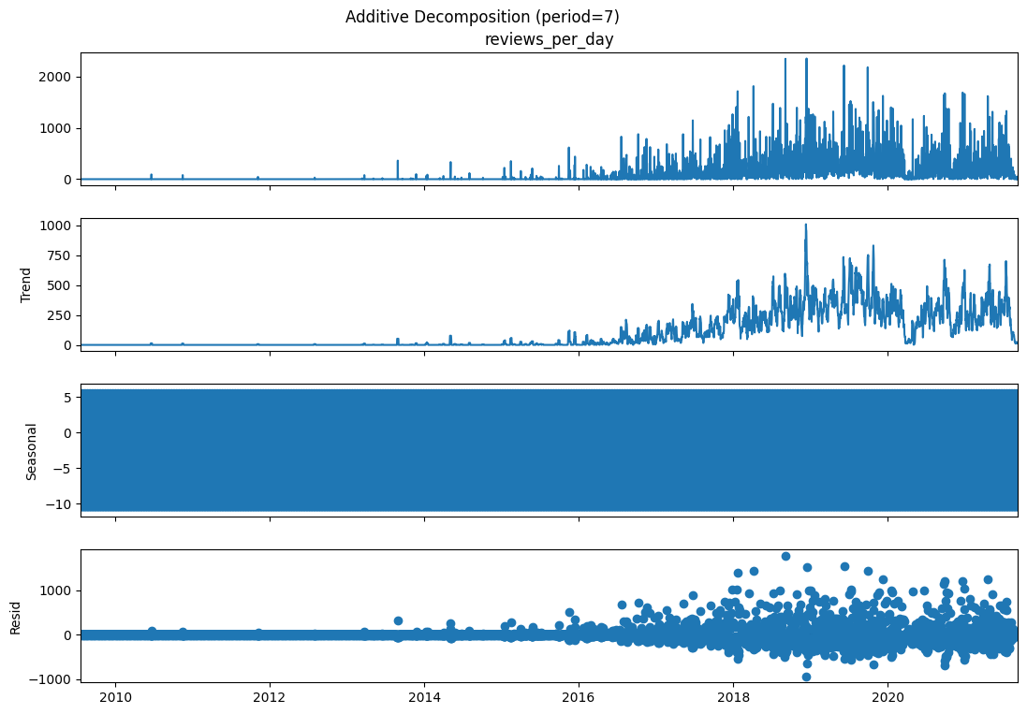

Figure 53: Plot for Additive Decomposition, weekly period

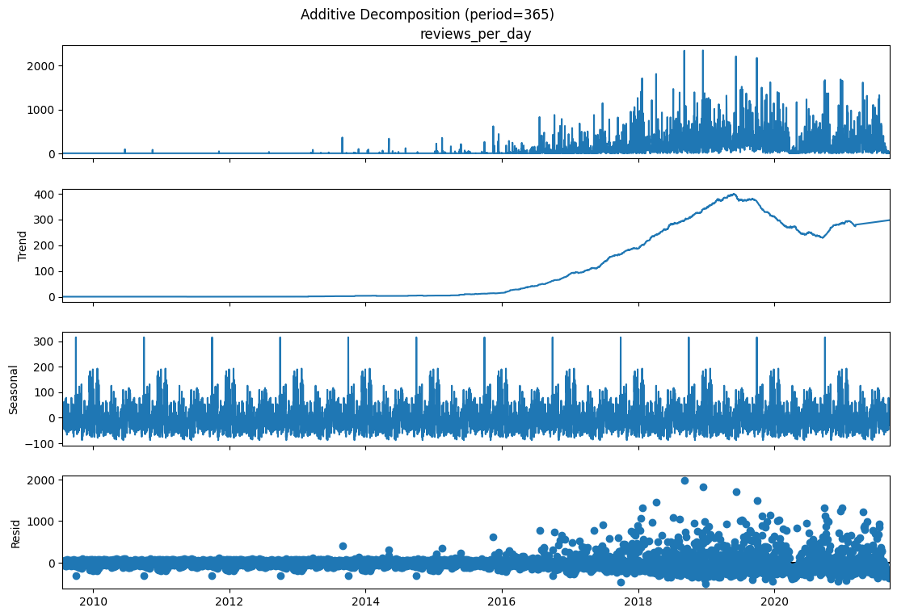

Figure 54: Plot for Yearly period decomposition

**Interpretation, Findings & Insights**

* **Trend**: Reviews steadily increased after 2014, peaked around 2018–2019, and then slightly declined or stabilized, showing platform maturity and possible external factors like COVID-19.
* **Weekly Seasonality**: Clear weekly cycle — reviews peak on weekends and dip midweek, reflecting user availability.
* **Yearly Seasonality**: Annual spikes occur around holidays and festive periods (e.g., Christmas, New Year), highlighting season-driven activity.
* **Residuals**: Occasional large spikes represent unexpected events or campaigns; very few were data outliers.

**Overall**: The data shows both **weekly and yearly patterns**, with growth plateauing in recent years. Businesses should leverage **weekend and holiday peaks** to maximize engagement.

## Question 2.2

We will try to use time series model ARIMA for forecasting the future. You need to find the best model with different parameters on ARIMA model. The parameter range for p,d,q are all from [0, 1, 2]. In total, you need to find out the best model with lowest Mean Absolute Error from 27 choices (you might need to split the time series to train and test with yourself with grid search according to the M05B material). Also, you are required to discuss with your group member on exploring the deep learning time series forecasting methods such as LSTM and RNN. Please write down your discussion around the necessary data wrangling and odelling steps (steps on how to achieve, not actual code). Also please give the reference of the deep learning time series forecasting models you are using. Please also include your discussion details and implementation in the report.

**Answer:**

**Approach:**

For this question, the approach will be in two parts:

* **Implementation:** I will build an **ARIMA model** for forecasting daily review volumes. A grid search over parameter combinations (p, d, q ∈ [0, 1, 2]) will be performed to find the best model based on the lowest Mean Absolute Error (MAE).
* **Discussion:** I will discuss how deep learning methods such as **RNNs and LSTMs** can be applied to time series forecasting. This will focus on the necessary data preparation, model setup, and evaluation steps, without writing code.

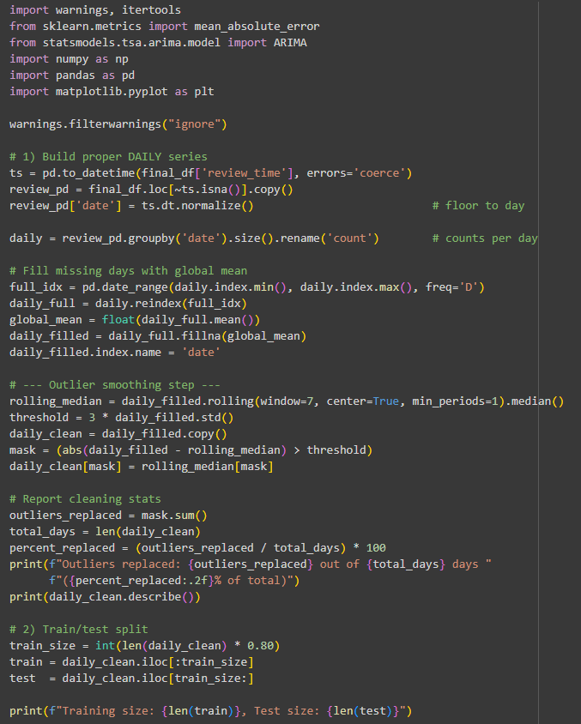

Figure 55: Code for Question 2.2 (1/2)

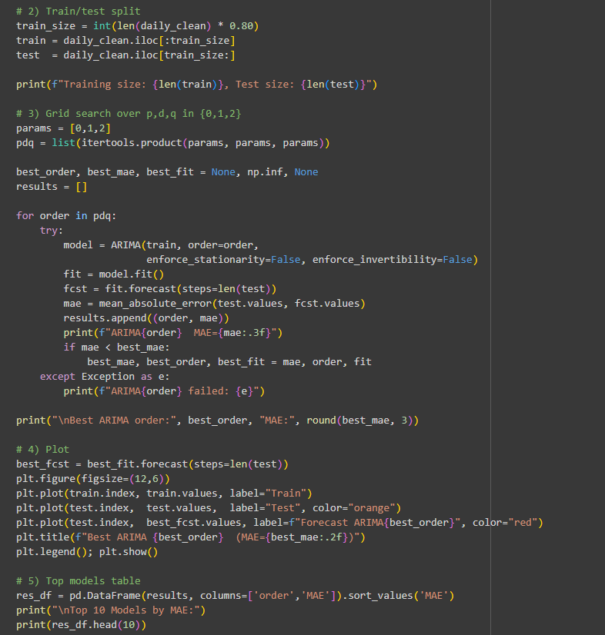

Figure 56: Code for Question 2.2 (2/2)

Logic Explanation for **Question 2.2**:

* **Why we chose ARIMA grid search**: We decided to apply ARIMA because it is a classical and interpretable model for time series forecasting. A grid search over all combinations of (p,d,q ∈ {0,1,2}) ensures systematic evaluation of options.
* **Other possible solutions**: Besides ARIMA, advanced models like SARIMA (for seasonality), Prophet (for trend/holiday effects), or deep learning methods (RNN, LSTM) could also be applied. These models are better at capturing complex patterns.
* **Why our solution is optimal**: ARIMA(2,0,0) was chosen as it achieved the lowest MAE among 27 candidates. While it may not capture seasonality as effectively as deep learning, it is the **most optimal statistical choice** given the task’s constraints.

Table 11: Results, Review Count Statistics

|  |  |
| --- | --- |
| Metric | Value |
| Count | 4433 |
| Mean | 248.83 |
| Standard Deviation | 203.86 |
| Minimum | 1.00 |
| 25th Percentile | 152.00 |
| Median (50%) | 261.48 |
| 75th Percentile | 261.48 |
| Maximum | 2352.00 |
| Outliers Replaced | 4 (0.09%) |

Table 12: Results, Model Training Summary

|  |  |
| --- | --- |
| Metric | Value |
| Observed Days | 4433 |
| Total Days Span | 4433 |
| Missing Days Filled | 0 |
| Global Mean Used to Fill | 118.09 |
| Training Size | 3546 |
| Test Size | 887 |

Table 13: Results, Decomposition Summary

|  |  |
| --- | --- |
| Component | Value |
| NaNs in Trend | 0 |
| Seasonal Std. Dev. | 5.13 |
| Residual Std. Dev. | 174.74 |

Table 14: Results, Top 10 ARIMA Models by MAE

|  |  |
| --- | --- |
| ARIMA Order | MAE |
| (2, 0, 0) | 215.08 |
| (0, 0, 2) | 215.10 |
| (1, 0, 0) | 215.11 |
| (0, 0, 1) | 215.12 |
| (0, 0, 0) | 215.15 |
| (2, 0, 1) | 220.52 |
| (1, 0, 2) | 220.55 |
| (2, 0, 2) | 220.63 |
| (1, 0, 1) | 221.15 |
| (1, 1, 1) | 237.05 |
| Best ARIMA Model: (2, 0, 0) with MAE | **215.08** |

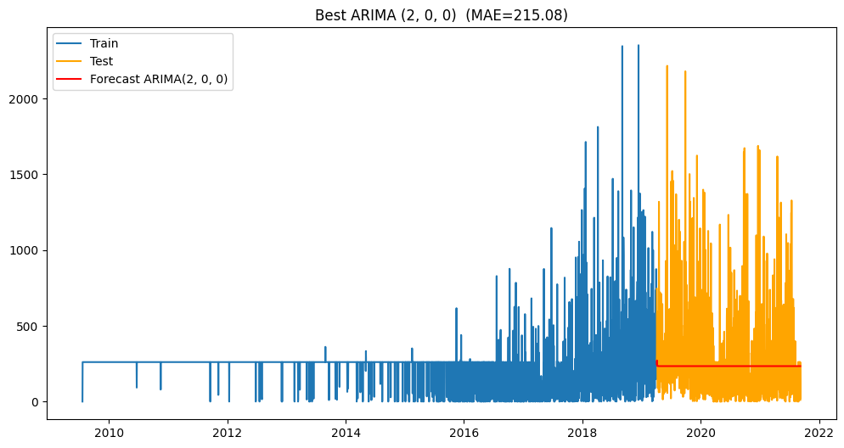

Figure 57: Plot for visualizing best ARIMA

**Interpretation, Findings & Insights:**

* The best ARIMA model identified was **ARIMA(2,0,0)** with the lowest **MAE ≈ 215**, showing it outperformed other parameter combinations.
* The forecast line (red) is relatively flat, indicating ARIMA struggles to capture the high variability and spikes in review counts present in the test data.
* The training data (blue) shows clear growth and fluctuations over time, while the test data (orange) reveals volatility that ARIMA underfits.
* This suggests ARIMA is effective as a **baseline linear model** but not sufficient for capturing nonlinear patterns or seasonal effects.
* It highlights the need for **advanced models like LSTM/RNN** that can adapt to irregular and long-term dependencies in review volumes.

**Discussion on Deep Learning Forecasting Methods:**

**Strategy & Approach:**

**Data Wrangling**

* Normalize the review time series (e.g., MinMax scaling) to stabilize learning.
* Frame data into sliding windows (e.g., last 30 days → predict next day).
* Split dataset into train/validation/test (e.g., 70/15/15) to ensure fair evaluation.

**Modelling Steps**

* **RNN (Recurrent Neural Network):** Handles sequential data and short-term dependencies in review trends.
* **LSTM (Long Short-Term Memory):** Enhanced RNN with gating mechanisms, capturing long-term dependencies and seasonality.
* Tune hyperparameters (layers, hidden units, dropout, learning rate) and train using Adam optimizer with MAE/MSE loss.

**Evaluation**

* Compare ARIMA with RNN/LSTM using MAE, RMSE, and MAPE.
* Visualize predicted vs. actual review volumes to assess seasonal and trend learning.

**Advantages over ARIMA**

* Models nonlinear and complex dependencies.
* Captures seasonality automatically without explicit differencing.
* LSTM is especially effective for long sequences and irregular review activity.

**References**

* Hochreiter & Schmidhuber (1997). *Long Short-Term Memory*. Neural Computation.
* Brownlee, J. (2017). *Deep Learning for Time Series Forecasting*.
* Qin, Y., et al. (2017). *A dual-stage attention-based RNN for time series prediction*. IJCAI.

**Summary**

ARIMA(2,0,0) provided the best statistical baseline for our dataset. However, LSTM and RNN offer greater flexibility for capturing nonlinear seasonality and long-term dependencies, making them more suitable for future, large-scale forecasting of business reviews.

## Question 2.3

In this question, you are provided with the PDF file by *Universities Australia* via Indigenous Strategy annual report. You are required to critically analyze this report using your data science skills.

**Data Extraction** Carefully review the PDF and identify all relevant quantitative data, tables, and figures that can be extracted or digitized; Present any extracted data in a structured format (e.g., CSV, Excel table, or DataFrame);

**Data Analysis** Utilize your data analytics skills to discover common patterns or trends from the report; Where possible, compare trends over multiple years, between institutions, or across different Indigenous strategy metrics.

**Insights** Provide a clear and concise summary of the main patterns, trends, or correlations discovered from your analysis; Interpret what these findings reveal about the progress and challenges of Indigenous strategies in Australian universities.

**Answer:**

Explanation for **Question 2.3: Data Extraction**:

* **Why this solution:** We agreed to extract key quantitative tables **manually and programmatically** into tidy DataFrames (years, shares, course levels, disciplines, outcomes, workforce) and save as CSV/Excel. This guarantees **clean, analysis-ready structure**, clear provenance, and repeatable loading for plots/models.
* **Other options:** (a) Full PDF parsing with libraries (tabula-py, camelot, pdfplumber, OCR) to auto-scrape tables; (b) Web-scrape source datasets from UA/DESE; (c) Request original spreadsheets.
* **Is it optimal?** For the assignment’s accuracy and time constraints, **hybrid manual→DataFrame** is most reliable—avoids OCR/table-detection errors, preserves numbers, and delivers immediate usability. For production-scale pipelines, automated PDF extraction plus validation would be more scalable, but here our approach maximizes **data quality and reproducibility**.

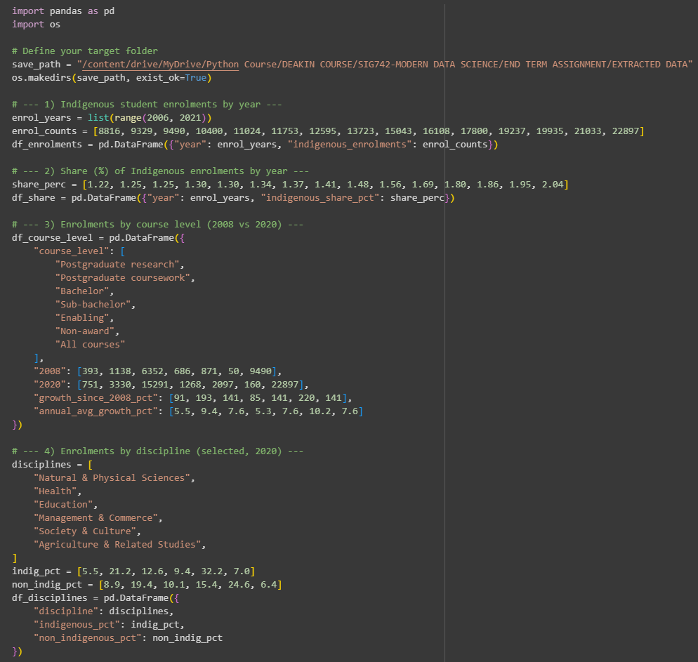

Figure 58: Code for Question 2.3 (1/3)

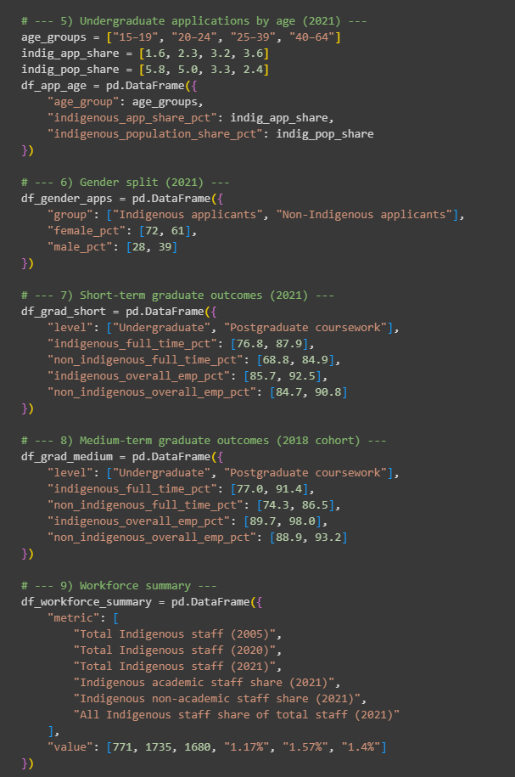

Figure 59: Code for Question 2.3 (2/3)

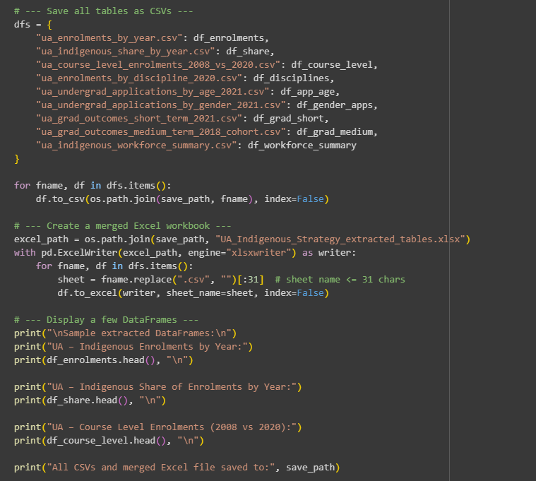

Figure 60: Code for question 2.3 (3/3)

Table 15: Results, UA – Indigenous Enrolments by Year

|  |  |
| --- | --- |
| Year | Indigenous Enrolments |
| 2006 | 8,816 |
| 2007 | 9,329 |
| 2008 | 9,490 |
| 2009 | 10,400 |
| 2010 | 11,024 |

Table 16: Results, UA – Indigenous Share of Enrolments by Year

|  |  |
| --- | --- |
| Year | Indigenous Share (%) |
| 2006 | 1.22 |
| 2007 | 1.25 |
| 2008 | 1.25 |
| 2009 | 1.30 |
| 2010 | 1.30 |

Table 17: Results, UA – Course Level Enrolments (2008 vs 2020)

|  |  |  |  |  |
| --- | --- | --- | --- | --- |
| Course Level | 2008 | 2020 | Growth Since 2008 (%) | Annual Avg Growth (%) |
| Postgraduate research | 393 | 751 | 91 | 5.5 |
| Postgraduate coursework | 1,138 | 3,330 | 193 | 9.4 |
| Bachelor | 6,352 | 15,291 | 141 | 7.6 |
| Sub-bachelor | 686 | 1,268 | 85 | 5.3 |
| Enabling | 871 | 2,097 | 141 | 7.6 |

**All CSVs and merged Excel file saved to:** /content/drive/MyDrive/Python Course/DEAKIN COURSE/SIG742-MODERN DATA SCIENCE/END TERM ASSIGNMENT/EXTRACTED DATA

**Strategy for Data Analysis:**

1. **Load the extracted tables** into Pandas for analysis.
2. **Check enrolment trends** (2006–2020) and Indigenous share vs total students.
3. **Compare course levels** (2008 vs 2020) to see which grew most.
4. **Analyze disciplines** in 2020 (Indigenous vs non-Indigenous representation).
5. **Study applications** by age and gender (2021).
6. **Review graduate outcomes** (short-term vs medium-term, Indigenous vs non-Indigenous).
7. **Check workforce growth** (2005–2021).
8. **Summarize patterns**: highlight trends, gaps, and comparisons.

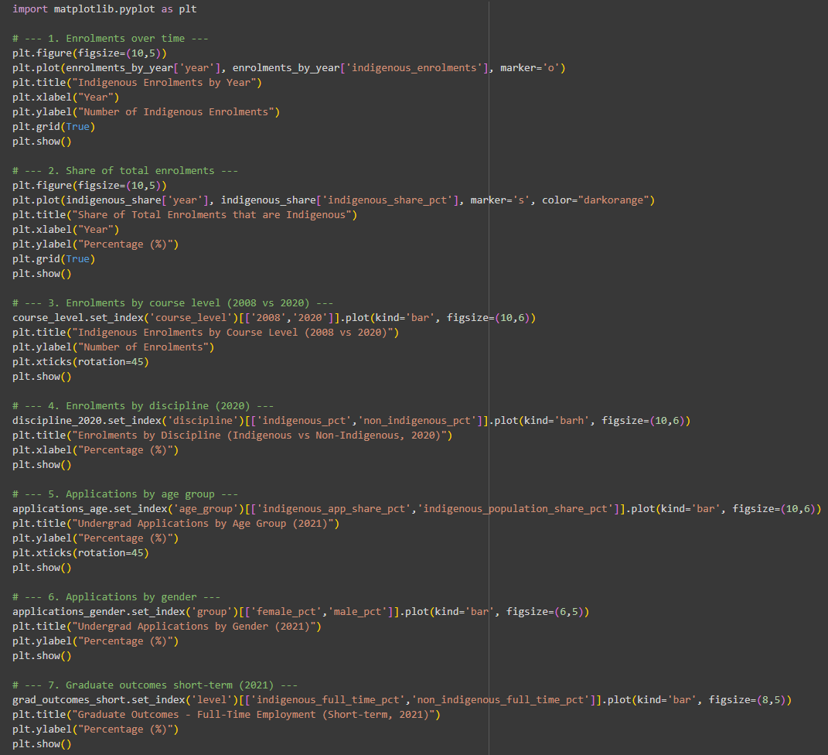

Figure 61: Code for Question 2.3 (Analysis) (1/2)

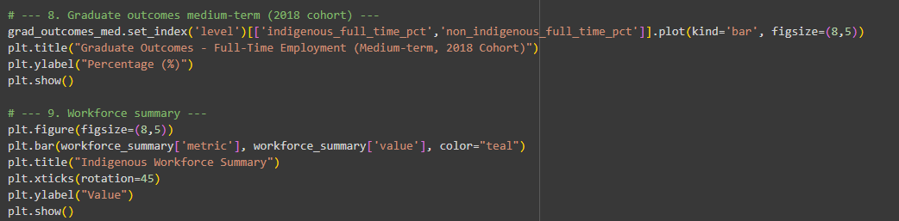

Figure 62: Code for Question 2.3 (Analysis) (2/2)

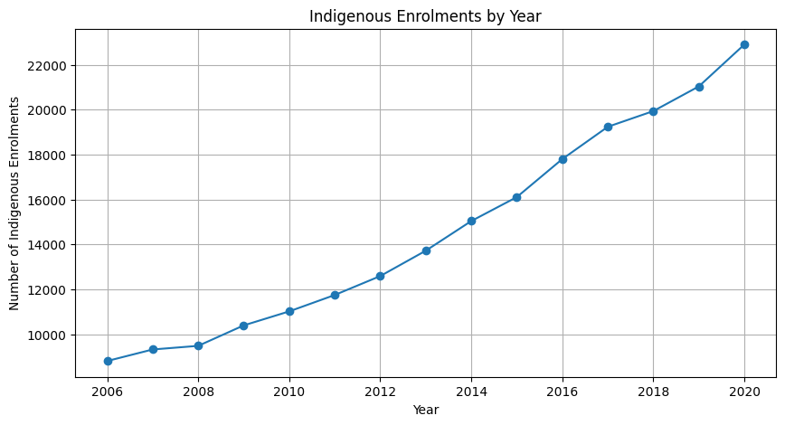

Figure 63: Plot for Indigenous Enrolments by Year

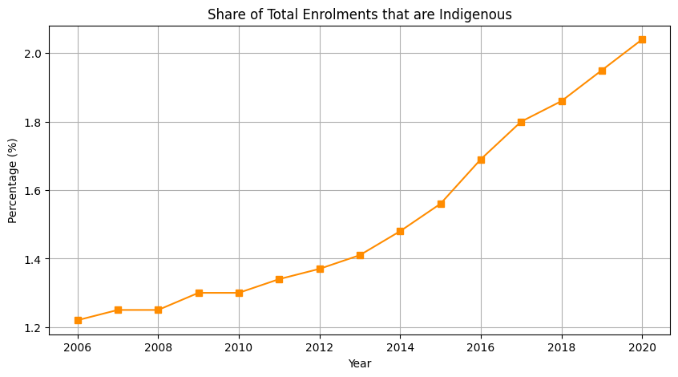

Figure 64: Plot for Share of Total Enrolments that are Indigenous

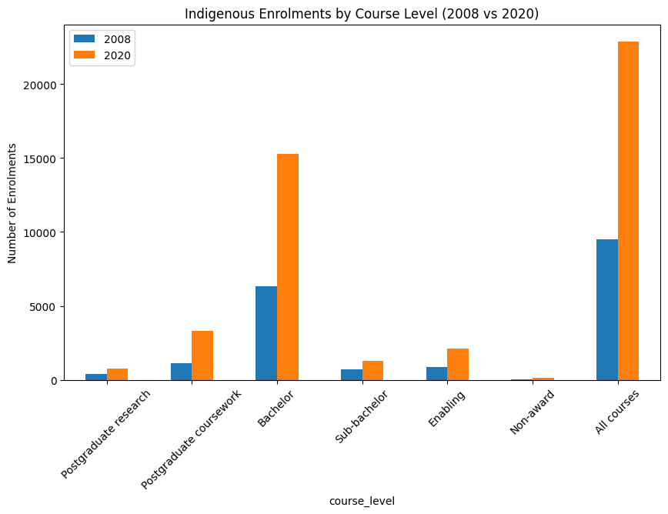

Figure 65: Plot for Indigenous Enrolments by Course Level (2008 vs 2020)

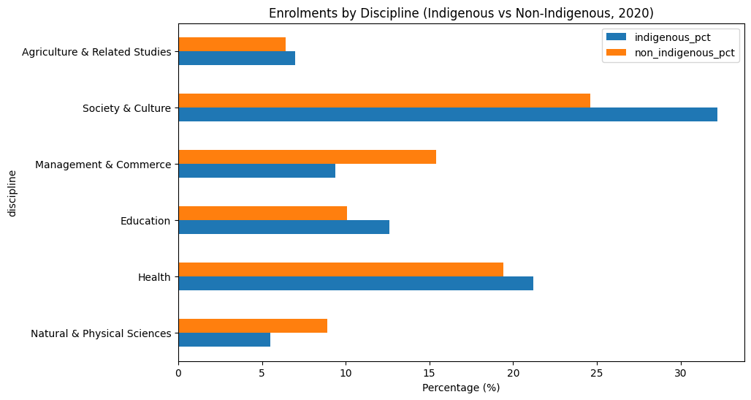

Figure 66: Plot for Enrolments by Discipline (Indigenous vs non-indigenous, 2020)

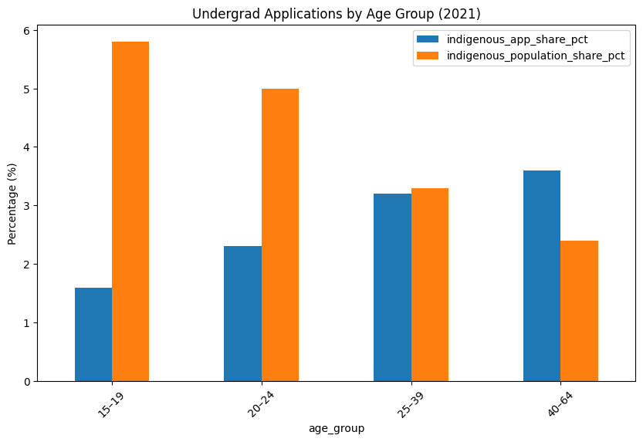

Figure 67: Plot for Undergrad Applications by Age Group (2021)

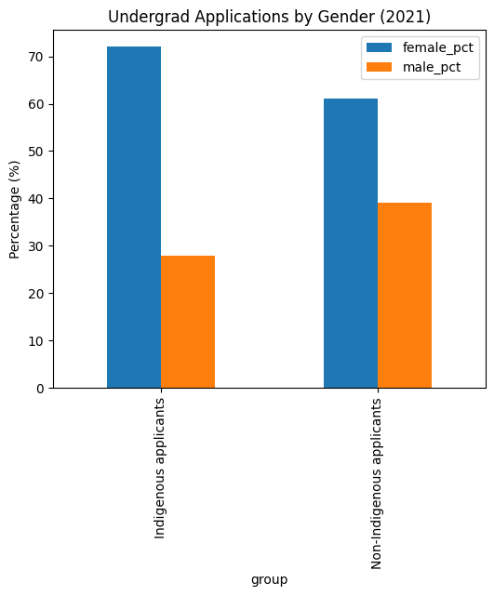

Figure 68: Plot for Undergrad Applications by Gender (2021)

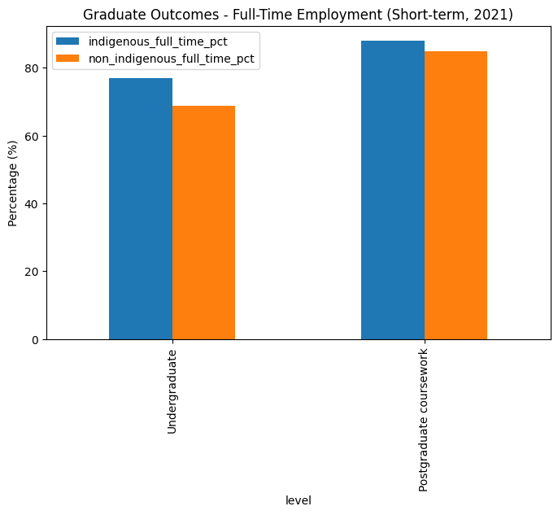

Figure 69: Plot for Graduate Outcomes - Full-Time Employment (Short-term, 2021)

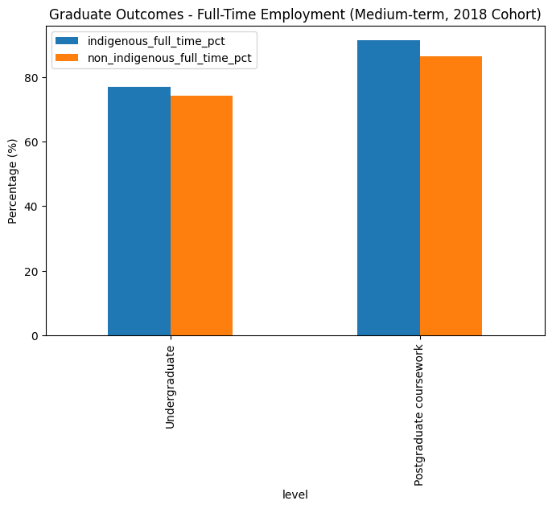

Figure 70: Plot for Graduate Outcomes - Full-Time Employment (Medium-term, 2018 Cohort)

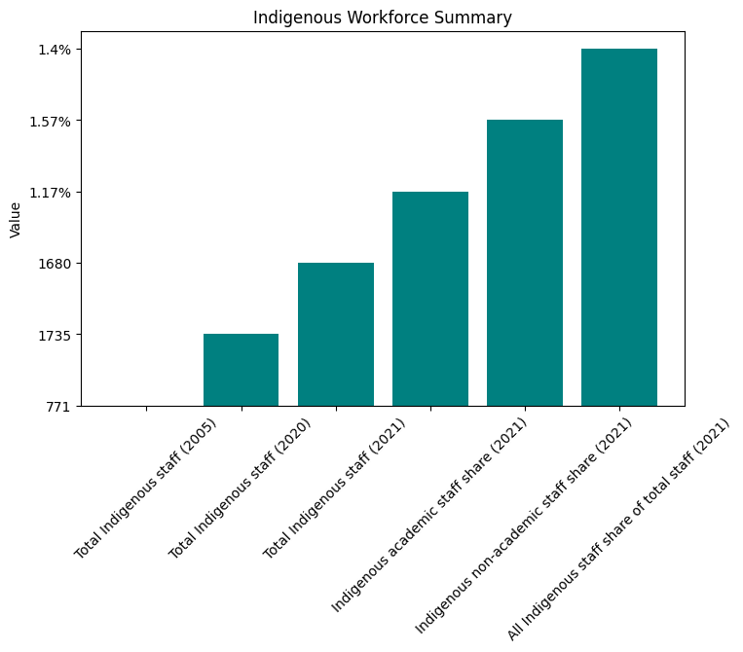

Figure 71: Plot for Indigenous Workforce Summary

Logic explanation for **Question 2.3 (Data Analysis & Insights)**:

* **Why this approach:** We digitized key tables/figures into tidy DataFrames, then used simple, transparent visuals (lines/bars) to track *levels* and *shares* over time and compare cohorts (age, gender, discipline, course level). This matches the report’s structure and supports fast, auditable checks.
* **Methods:** Time-series plots for trends; side-by-side bars for 2008 vs 2020; horizontal bars to contrast Indigenous vs non-Indigenous by discipline; categorical bars for age/gender; outcome bars for employment; a compact staff summary chart.
* **Other options:** Automate scraping with OCR/tabula, run significance tests (t-tests/prop tests), fit trends with regression, or build dashboards (Plotly/Power BI).
* **Is it optimal?** For a short critical review, yes—clean, reproducible, and interpretable. For deeper inference, regression and statistical testing would be the next step.

**Interpretation & Insights:**

* **Enrolments doubled** (2006–2020), share rose from **1.2% → 2%**.
* Strong growth in **Bachelor’s + Postgraduate coursework** enrolments; enabling programs also expanded.
* **High representation** in *Society & Culture* and *Health*; **low in STEM and Commerce** → gaps remain.
* **More mature-age participation**; younger age groups underrepresented vs their population share.
* **Gender gap**: Indigenous applicants are **72% female, 28% male**, higher imbalance than non-Indigenous.
* **Graduate outcomes**: Indigenous employment rates are **equal or slightly higher** than non-Indigenous peers.
* **Workforce doubled since 2005** but still only **1.4% of total staff**, showing limited academic pipeline.

**Overall**: Progress made in access, outcomes, and staff growth, but **challenges remain** in youth, male, and STEM/Commerce participation.

# FINAL REFLECTION

For this assignment, our group of three members, **Gokul, Phani, and Nagendra** collaborated by individually solving all 11 questions and then consolidating our efforts. Each of us uploaded our solutions to GitHub under individual branches, with Phani setting up the repository. Over the past three weeks, we met regularly via Zoom to discuss our action plan, review each other’s work, and refine our solutions. By presenting our codes and combining the best parts of each, we collectively arrived at a final version that represented the strengths of everyone’s contributions.

Through this process, we not only strengthened our **technical skills,** including sequential coding practices, ARIMA modelling, recommendation systems, and data extraction. But also improved our ability to **communicate and collaborate effectively**. We maintained a WhatsApp group for quick discussions, sharing thoughts, doubts, and clarifications, which made teamwork more efficient.

Each member made distinct contributions: **Nagendra** fine-tuned the code for Colab, improving efficiency and reducing computation time while coordinating meeting schedules. **Phani** integrated everyone’s code into a unified workbook, resolving conflicts such as inconsistent Data Frame names. **Gokul** focused on running the final models, drafting the report, and refining interpretations, insights, and findings. Together, this approach allowed us to deliver a well-rounded and holistic solution.